Date:-27-Aug-2022

# SHERY NAVEENKUMAR

Mobile: - +971501486231, +971506759075

Email: [sherynaveenkumar@gmail.com](mailto:sherynaveenkumar@gmail.com)

Sharjah, United Arab Emirates

**RE:- ACCOUNTANT**

I am submitting herewith my resume for your perusal and favorable consideration for the post of “**Accountant**"

in your organization.

Review of my credentials indicates that I am having a Bachelor Degree in commerce from Calicut University

Kerala & MBA finance from Bharatiar University. Possess comprehensive knowledge of computerized accounting

software's, **Tally ERP9, Orison, MS Office & Profit.**

I have more than 8+ years (UAE) of experience in accounting field.

With exceptional communication and interpersonal skills, innovative approach and quick adaptability to changing

processes and trends have been my biggest assets.

I am seeking a challenging job to utilize my skills and experience with the objectives of the organization.

The above credentials along with my enclosed resume make me ideally suitable for a position in your

organization. I would appreciate an opportunity for a personal interview.

Thanking you in anticipation of a favorable reply.

Yours sincerely

# Shery Naveenkumar

**SHERY NAVEENKUMAR**

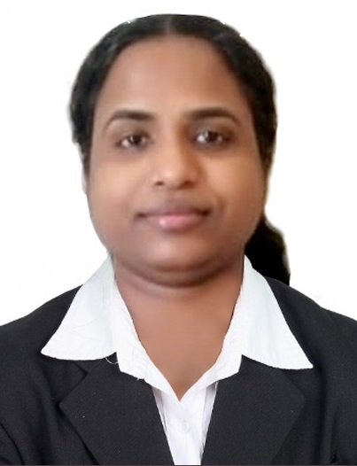

Mobile : 0501486231,0506759075 (UAE)

Email : [sherynaveenkumar@gmail.com](mailto:sherynaveenkumar@gmail.com)

: Sharjah,UAE

## OBJECTIVE:-

Seeking a position in Accounts & Finance Department to use my education & experience as an asset in growth of the organization, the ideal environment professionally stimulating and will offer opportunity for carrier advancement.

## PROFILE:-

* 8+ years experience in Accounts & Finance in UAE.
* Ability to work in accounts & finance department.
* Well in computerized accounting environment like **Tally ERP 9**, **MS office**, **Orison**, **Profit**.
* Proficient in accounts finance & functions.
* Have the ability to quickly identify the problems and provide appropriate solution.
* Energetic & self motivated with a high degree of cultural sensitivity.
* Detail oriented, efficient & organized professional with an extensive experience in accounting system.
* Resourceful in completing projects & efficient in multi tasking.

## EMPLOYMENT HISTORY:-

Accountant - M/s Arab Cal Group LLC - (Sharjah) (From - Oct 2021 to April 2022)

Accountant Accountant Accountant

- M/s Greens Telecom Trading LLC- (Dubai)

* + M/s Royal Screen Trading LLC - (Dubai)
  + M/s Rising Star Automobiles LLC- (Dubai)

(From - July 2016 to May 2021) (From - April 2012 to April 2014) (From - Jan 2011 to March 2012)

Asst.Accountant - M/s Ras Al Khor Contracting LLC- (Dubai) (From - Sep 2007 to May 2008)

## DUTIES & RESPONSIBLITIES:-

* Assistance and co-ordination with the financial activities with Accounts Manager.
* Preparation of P & L and balance sheet and the monthly income summary and P & L Account and presenting

the same to the management.

* Incorporation of new leases with the leading Companies and Banks.
* Dealing with Banks in respect of Pledges, release of raw material and other daily transactions.
* Preparing and posting of accruals and journal voucher in accounts.
* Process outgoing payments with financial policies and procedures.
* Day to day financial transactions, verifying and recording accounts payable data.
* Preparing monthly, quarterly and annual reports.
* Understanding compliance issues around accounts payable.
* Documentation & finalization.
* Maintaining the receivable/payable of the companies and follow-up reports, assist in The bank reconciliation related the accounts department on daily & monthly.
* Assist in the daily deposits/collection and payments of the company accounts.
* Reconciliation of ledgers with dealers/parties.
* Preparing statement of current affairs on daily basis.
* Overseeing the overall accounts of the company.
* Supervision of sales & purchase invoices.
* Prepare and issue receipts voucher (cash & cheque) along with entry.
* Organize & manage system of filling documents related to finance and confidential documents.
* Preparation of quantitative records sales and purchase and its reconciliation.
* Deals with marketing dept for payment matter.
* Manage payroll with automated payroll function.
* Printing of cheque payments.
* Maintain daily cash book, record of tax, social security etc.
* Preparation monthly confidential sales reports for presentation to management.
* Collection and clearing of cheque of other department and transfer of funds.
* Issuance of bank certificate and statement and handling of foreign remittance
* Help create company budgets and complete review of tax return.
* Safe keep the company registration documents -Trade license, Tenancy contract etc.
* Issue supplier payment based on agreement.
* Handling main petty cash.
* To receive and retain invoices, bank documents and all important finance documents from

internal documents.

## EDUCATIONAL ACHIEVEMENTS:-

* Diploma in Computer Application & Business Management (3years) Kerala in 2000.
* Bachelor of commerce (B-com) from Calicut university kerala India in 2003.
* IATA / UFTAA (Consultant diploma certificate-Montreal Canada), Kannur, India in 2010.
* MBA - Finance from Bharatiar university- India in 2019.

## PERSONAL DATA:-

Date of Birth : 27-05-1980

Marital Status : Married

Language Known : English, Hindi, Malayalam

Nationality : Indian

Passport No : N7704597

Visa Status : Husband Sponsorship

Contact Address : Muweileh,Sharjah-UAE

## DECLEARATION:-

I hereby declare that all the information furnished in this document is true to my Knowledge and belief.

**Shery Naveenkumar**

## ‐‐‐‐‐‐‐‐‐‐‐‐‐‐‐‐‐‐‐‐‐‐‐‐‐‐‐‐‐‐‐‐‐‐‐‐‐‐