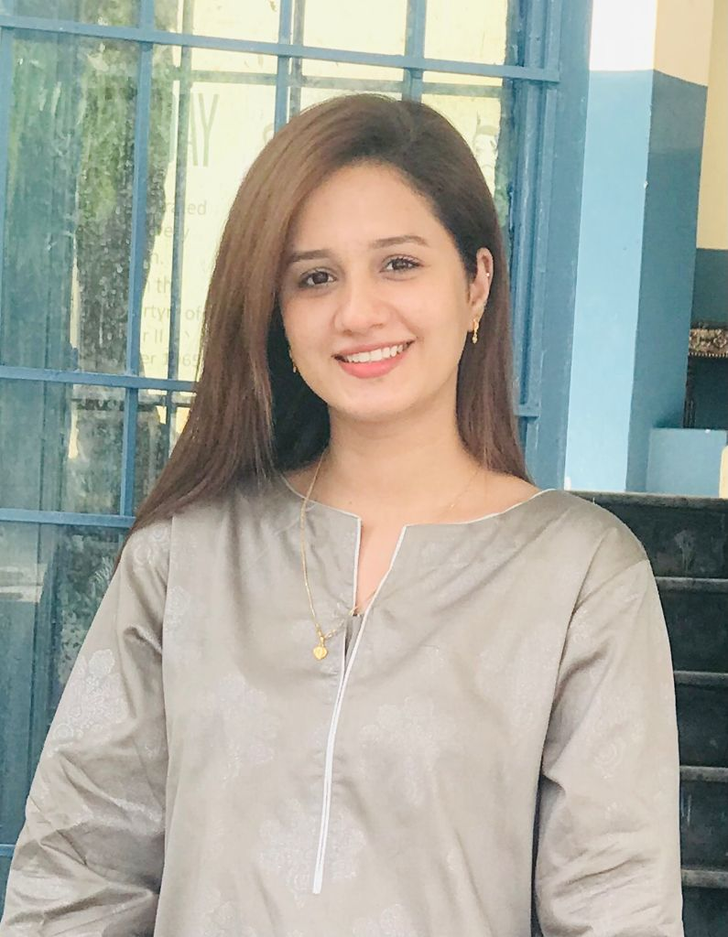 |  | SHAZMA KHALID  “Health Makes Happy “
Profile  Dietitian/Nutritionist  Fitness trainer/coach  Writer, Blogger  Administrator  Contact  PHONE:  - +92 3038594996 WhatsApp only  - 009714115397  - EMAIL:  Umaimaj223@gmail.com  ShazmaKhalid01@gmail.com  - Address:  - Al Yasmeen Tower flat 528 tower A opposite Ajman city center Ajman  Hobbies  - Reading  - Listening music  - Painting  - Traveling |  | EDUCATION  School:  Decent Caliber High School – Faisalabad 2013  College:  FSC pre-medical - Faisalabad 2014 to 2016  University:  DDNS 5-year program( Bachelors)- Doctors of Dietetics and Nutritional Sciences-The University of Lahore- Lahore 2016 to 2021  Masters – Masters in Public Health –University of Suffolk -Ongoing  - Certificates:  - Essentials of Public Health Administration – University of Acacia-USA-Level 7  - Mastering Health and Safety Management- University of Acacia -USA-Level 7  - SAQA Certificate -NQF level 8- South African Qualification Authority  - Public Health Nutrition- University of the Incarnate Word  - The MMR Vaccine, Public Health, and Private Fears- The Open University – UK-Level 3  - Substance Use and Public Health-Approved by NAADAC-NextGenU.org  - Understanding Service Improvement in Health Care- The Open University – UK- Level 3  - Public Health Leadership-PAHO (PAN AMERICAN HEALTH ORGANIZATION)- WHO-University of the Incarnate Word  - Promoting Health in the Population PHP-CQ –London School of Planning and Management-UK  - Caring Manager in Health and Social care- The Open University – UK-Level 2

WORK EXPERIENCE:

1.06.2018 31.08.2018 Sheikh Zaid Hospital, Lahore

28.05.2019 Also work in an orphan home

25.08.2020 25.09.2020 Farooq Hospital, Lahore

October 2020 March 2021 Ganga Ram Hospital, Lahore
October 2020 April 2021 Shaddrah Government Teaching Hospital, Lahore
May 2021 December 2021 The University Of Lahore Teaching Hospital
Online Consultations
- Expertise:
- Assess clients' nutritional and health needs.
- Counsel clients on nutrition issues and healthy eating habits.
- Develop meal and nutrition plans, considering clients' preferences and budgets.
- Evaluate and monitor the effects of nutrition plans and practices and make changes as needed.
- Expert in medical nutrition therapy also focuses on preventing health conditions through proper nutrition and education. Other conditions they may address in clients include bariatric surgery, kidney issues, and working with sports nutrition/optimal nutrition for athletes.
- Contributing to ensuring that quality control, acceptability, and hygiene standards are adhered to. Ensuring optimal nutrition by nutritional analyses of menus. Recipe development and recipe standardization..
Worked with many health communities /Sectors
2 years of Customer Care Assistance Experience
Worked as a Gym trainer/Fitness Trainer/Coach
- 5 years of writing experience
- SEO Content writing
- Creative and unique writing
- Blog posts
- Research articles (Literature review, mini-articles, and published articles)
- Website content
- Amazon Affiliated articles
- Health care related, Medical, Physical and Fitness, Mental And Psychological, Business, Travel, and others
- Freelancing (Currently working on Fiverr and Upwork with Individuals and Companies)
- As a Full-time and part-time
- Works As a head and coordinator of the Young Leadership Program
Social media:
Instagram dr.shazma_khalid - Facebook: Shazma Khalid

Skill
- Assessment with all physical findings
- Know how to use all vital tools
- Counseling
- Make good and healthy plans according to health issues and budget preferences
- Management experience
- Ability to face and tackles every worst and critical situation
- Administration and coordination
- Motivated Well- Disciplined Individual
- Find Joy In Addressing the Right Audience Helping Them In their Growth
- Computer skills (MS Word, Excel, PDF, Canvas)
- Costumer Care Assistance Skill
- Presentations
- Knowledge In Conversational
- Critical thinker
- Good in communication

