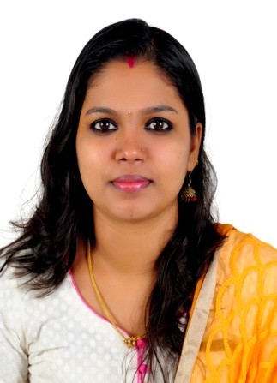 **SONU S PILLAI**

**4.4 YEARS OF EXPERIENCE IN SALES/ RESERVATION CUSTOMER SERVICE/OFFICE ADMINISTRATION**

Email ID:

Contact:

[Sonuspillai1993@gmail.com](mailto:Sonuspillai1993@gmail.com)

+971-56-6977681

**Overview**

* Experienced Customer Service, Reservation & Office Administration.
* Understanding the requirements of customers and handling customer queries.
* Experienced and motivated Customer Service representative with 1 years of extensive experience in call center environments.
* Monitor incoming emails and answer or forward as required
* Document Controlling.
* Providing real time solutions to customers on verbal communication.
* Office Management and Office Coordination
* Participate in management meetings by contributing ideas for increasing performance, efficiency and client satisfaction.

**Strengths**

* Solid foundation on customer care and relations, with vast experience in the field.
* Strong interpersonal skills, with the ability to relate and empathize with people of varying personalities and from all walks of life.
* Fluency in the English language, with excellent communication skills both in verbal and oral communication.
* Proficiency in numerous computer applications and software, including MS Word, Power Point, Excel, and several others.
* Highly motivated and driven to achieve set goals and targets.
* Ability to maintain a calm and composed manner when dealing with potentially explosive client situations.
* Superb ability to multitask, able to handle multiple duties and responsibilities without sacrificing quality of work.
* Great team player and excellent independent worker

**Professional Experience**

**Admin Assistant & Customer Care**

**UAE Exchange & Financial Service Ltd (June 2015-2018)**

* Attending Visitors/Guests
* Sales Coordination as well as project coordination
* Office Management
* Office Coordination
* Meeting Coordination
* Making Quotations & Power Points.
* Supporting 300 + branches for accounting & ensuring proper delivery service.
* Document Controlling.
* Follow up all the office related works.
* Listening to customer requirements and presenting appropriately to make a sale;
* Maintaining and developing relationships with existing customers in person and via telephone calls and emails;
* Cold calling to arrange meetings with potential customers to prospect for new business;
* Responding to incoming email and phone enquiries;
* Acting as a contact between a company and its existing and potential markets;
* Gathering market and customer information
* Reviewing your own sales performance, aiming to meet or exceed targets;
* Gaining a clear understanding of customers' businesses and requirements;
* Making accurate, rapid cost calculations and providing customers with quotations

**Customer Care Executive**

**Chavara matrimony (2012-2014)**

**(World Largest Christian Matrimony)**

* Converts inquiries into sales by calling Targeted Customers
* Advises present or prospective customers by calling on a rotating basis; operating telephone equipment, automatic dialing systems, and other telecommunications technologies.
* Influences customers to buy or retain product or service by following a prepared script to give product reference information.
* Documents transactions by completing forms and record logs.
* Maintains database by entering, verifying, and backing up data.
* Keeps equipment operational by following manufacturer's instructions and established procedures; notifying team leader of needed repairs.
* Maintains operations by following policies and procedures; reporting needed changes.
* Maintains quality service by following organization standards.
* Contributes to team effort by accomplishing related results as needed.

**Achievement and Awards**

* **BEST EMPLOYER OF THE MONTH**(3 TIMES while working in Chavara Matrimony Call Centre )
* Head Girl (Higher Secondary Level)
* Sports Championship(Higher Secondary Level)

**Professional Qualification**

* **IATA UFTAA foundation diploma from Montreal, Canada.**
* **Diploma in GALILEO and AMADEUS**

**Education**

**BSc ATHM(Airline Tourism and Hospitality Management)-2014**

Punjab Technical University(PTU)

Chavara School of Management Studies

**All India Senior School Certificate Examination (12th)-2011**

Kerala Higher Secondary Examination Board.

SVGVHSS, Kerala

**State Board of Secondary Education (10th)-2009**

Central Public Examination Board.

MS HSS, Kerala,

**Language Skills**

**English:** Fluent

**Malayalam:** Fluent

**Hindi**: Beginner

**Personal Information**

Marital Status: Married

Nationality: Indian

Date of Birth: 27 Oct 1993

Religion: Hindu

Visa Status: Visit Visa