SANTHAN HARIDAS.N.P.

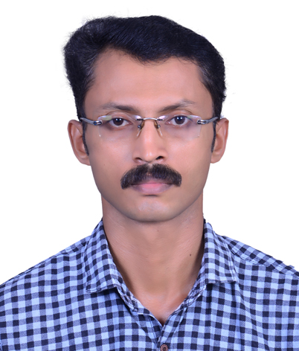

S/o N.P.Haridasan S.S.Nivas Cheleri

Post Kannur 670604, Kerala

Mobile 0523611924

Email [santhanharidasnp@gmail.com](mailto:Email%20%20%20%20%20%20%20%20%20%20santhanharidasnp@gmail.com)

## **Objectives**

To find a challenging position in a learning and friendly atmosphere to meet my competencies, capabilities, skills, education and experiences.

A highly focused, hardworking and co-operative person with about Five years of UAE experiences.

# Experience

Taxi Driver : Al Ghazal Transport, Abu Dhabi (one year)

Company Driver : Al Mufilh Engineering Sharjah (two years)

Worked as a driver for 2 years involved in Product deliveries , Collection of raw materials and sometimes in Purchase of sophisticated machine parts, tools and cutters. Has involved in final high tolerance and critical parts Packing also.

# Qualification

S.S.L.C G.H.S.S. Kannadiparamba

**Software**

MS Office, Photoshop, Adobe Premiere

# Languages Known

# English

Malayalam

Hindi

# 

# Personal Details

Date of Birth : 30/03/1983

Marital Status : Married

Nationality : Indian

# Passport Details

Passport No : K152755

Date of Expiry : 01-03-2022

Place of Issue : Kozhikode

**License Data**

License no/Type : 621025/Sharjah /Manual

Expiry date : 07/11/2026

Permitted Vehicle : Light Vehicle

Date: 17.04.2019

Santhan haridas N P