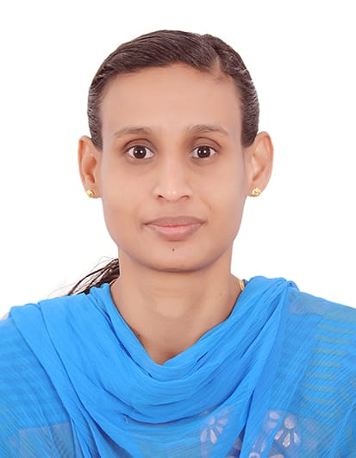

**CURRICULAM VITAE**

**SHINI K MATHEW**

**Mobile No: 0557925776, 0507930735.**

**Email:shinimathewk@gmail.com**

**RL No : 291120027138**

**OBJECTIVE** :

**Looking for a challenging position in a dynamic organization, where I can utilize my experience in the field of NURSING and for the development of the institution with in time in professional way utilizing my 17 Years experience.**

**Working experience : 17 Years**

**Position :Registered Nurse**

**HEALTH LICENCE**

**Authority Ministry of Health**

**Registration no RN184165**

**Expiry on 25 /11/2025**

**WORK EXPERIENCE IN UAE :**

**Presently working as a Registered Nurse in Medcare Hospital Sharjah in Emergency Derpartment from 1 May 2021 to till the date**

**Worked as a Registered Nurse in Central Private Hospital Sharjah in Emergency Department from 11 November 2013 to till 10 April 2021**

**Worked as a Registered Nurse in Al Barakah Clinic in Sharjah from 10 August 2011 to 15 March 2013.**

**WORK EXPERIENCE IN INDIA :**

**Worked as a staff nurse in SN Hospital, Thiruvalla, Kerala in the Department of ICU from 2March2010 to 20 Sep 2010.**

**Worked as a staff nurse in GENESIS Hospital Bangalore, Karnataka in the department of Medical & Surgical unit from 10 Feb 2008 to 17 Feb 2010.**

**Worked as a staff nurse in HOLY SPIRIT Hospital Mumbai in the Department of ICU/ICCU from 29 June 2005 to 29 Jan 2008.**

**Worked as a staff nurse in MAHARAJA AGRASEN Hospital Bangalore, Karnataka in the department of Medical & Surgical ward from June2004 to March2005.**

**PROFESSIONAL QUALIFICATION :**

|  |  |  |
| --- | --- | --- |
| **Course** | **Duration** | **University/Board** |
| **SSLC** | **1998** | **Board of public examination Kerala State** |
| **PDC** | **1998-2000** | **Mahatma Gandhi University** |
| **Diploma in General nursing**  **And Midwifery** | **2000-2003** | **Karnataka Nursing Council** |

**EQUIPMENT FAMILIAR WITH :**

**Ventilator**

**Clinical thermometer**

**Pulse oxymeter**

**Cardiac monitor**

**Infusion pumps**

**Suction apparatus (wall-Mounted and portable)**

**Oxygen apparatus (Wall-Mounted and portable)**

**Nebulizers**

**Chest drainage set, lumbar puncture set, CVP and Arterial set, Tracheostomy set**

**One-touch glucometer**

**Fluid infusion set**

**Resuscitation trolley**

**Oxygen head box**

**ABG Machine**

**Syringe pumps**

**Laryngoscope**

**ECG Machine**

**Course Attended:**

**Basic life support (BLS)**

**Date of Expiry : June 2024**

**Advanced Cardiovascular Life support ( ACLS)**

**Date of Expiry: February 2024**

**Peadiatric Advanced Life Support (PALS)**

**Date of Expiry :June 2026**

**PERSONAL DATA**

**Husbands Name : Binu M Alex**

**Date of Birth : 18Feb 1983**

**Marital status : Married**

**Sex : Female**

**Religion : Christian**

**Nationality : Indian**

**Languages known : English, Hindi, Malayalam & Kannada**

**Present Address : C/O Binu M Alex**

**PO Box 33015, Sharjah, U.A.E**

**PASSPORT DETAILS :**

**Passport Number U044467**

**Place of issue Dubai**

**Date of expiry 18/01/2030**

**VISA Status Husband visa**

**Date of expiry 21/01/2024**

**DECLARATION**

**The above declarations are true to the best of my knowledge and belief. All certified and credentials will be tendered on demand.**

**Place: Sharjah** **SHINI K MATHEW**