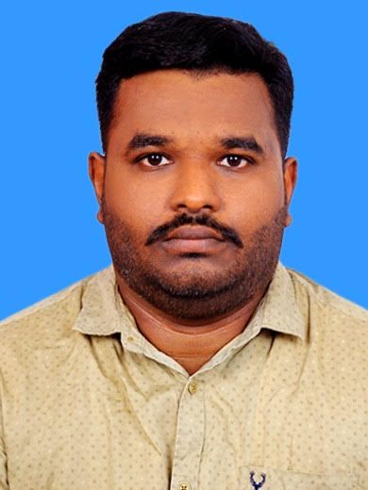

SREERAJSREEKUMAR

Email: sreeraj7730@gmail.com

Mob: +968 94332524 (Oman)
Mob: +919496851882 (India)

Present at Oman

Permanent Address

Thenguvila (H),

Ashtamudy ( P.O),

Kollam (Dt.),

Kerala (State) India.

PIN: 691602

Personal Data

Date of Birth : 22/03/1991
Sex : Male
Nationality : Indian
Marital Status : Single

Passport Details

Passport No : N 5424823
Place of Issue :Trivandrum
Date of Expiry : 14-12-2025
Driving license Issue: India
Visa stauts : upto 20/07/2023

CURRICULUM VITAE
Dedicated individual with 6.4 years’ experience in construction and administration. Currently looking for Administration or HR section job position with a progressive company where my skill and experience will be fully utilized

Academic and Technical Qualifications
Master of Business Administration in Human Resource Management (Awaiting result )
Bachelor of Business Administration
Course Completed in Civil Engineering from PSN College of Engineering Technology
Diploma in Civil QA/QC/QS & NDT From
Diploma in Professional Interior Designing

Trainings Completed
- Permit holder
- H2S Awareness and Escape
- Confined Space Entry Training
- OGC HSE Induction
- Petrofac HSE Induction
- AGT(authorised gas tester)

Computer Proficiency
- Microsoft Office- Ms Word, MS Excel, Power Point and Internet, Microsoft outlook.
.
Work Experience (6 .3Years)
Projects

2021- Till the date Target LLC- Oman (10 month)

Position : PERMIT CO COORDINATOR (Administration)
Project : J-171OGC Duqm Refinery EPC-2 package Project @ Duqm
Type of Project : Sub-contract to Petrofac
Place/ Country : Muscat- Oman
Client : Duqm Refinery Company
Project Value : 17 Million OMR

Job Profile- PERMIT CO COORDINATOR
- Communicating with clients or employers about project, event or campaign expectations and goals
- Delegating tasks to appropriate team members
- Managing deadlines and progress across the team to ensure the project is delivered on time and on budget
- Organizing third-party providers and vendors to deliver elements that can't be produced in-house
- Overseeing the delivery of projects and making adjustments as necessary to ensure they are delivered to specifications and high standards
- Collecting and analysing feedback from customers and other project users to gauge satisfaction and success

2019- 2021 Target LLC- Oman (1.8 Years))

Position : ASSISTANT QA/QC INSPECTOR
Project : J-167 OGC Permanent Staff Accommodation at Fahud
Type of Project : EPC- Building for an Oil and Gas Company
Place/ Country : Muscat- Oman
Client : OGC- Oman Gas Company
Project Value : 1 Million OMR

Job Profile- ASSISTANT QA/QC INSPECTOR
- The preparation of the companies QA manual control and supervision of all amendments and revisions
- Control and the distribution of all the company’s quality documentation
- Monitor all quality related activities on the project
- Perform all internal and external audits on behalf of the company’s management
- Verify contractor quality requirements are specified to vendors and contractor documentation submittals.
- Attend all pre-bid meetings and coordinate all project requirements with the project bidders.
- Attend client quality management meetings
- The preparation and control of project quality system management documentation prior to project commencement.
- Review quality inspection personnel qualifications and training requirements
- Monitor the disposition of all issued non-conformance reports.
- Monitor the progress and effectiveness of the project quality management system. Recommend and implement improvements when required.
- Coordinate all QA/QC activities with the site QC manager
- Coordinate all QA/QC activities with the site Project manager
- Coordinate all quality related correspondence with the customer’s representatives.
- Monitor statistical method reporting.
- Action and close all customer complaints
- Control all achieve documentation upon the completion of the project

2018- 2019 S&G ENGINEERING (1.2 Years)

Position : Supervisor cum site administration
Project : Kollam bypass project Type of Project : bridge protective coating
Place/ Country : Kollam, Kerala- India

Client : CherianVarkey Construction Company

Ensure a consistently high standard of work is produced in accordance with specification and quality standards through regular quality inspections with sub-contractors. Direct and supervise day to day operations of sub-contractors ensuring appliance of common operational procedures. Ensure material requisitions are issued in adequate time to achieve the Construction Program. Schedule, control and monitor all plant and materials on a weekly basis. Ensure all work is completed to program. Liaise with Contracts Manager/Project Manager, Site Manager/Agent, and Contract Surveyor regarding work variations and confirmation of instructions. Carrying out safety inspections and fulfilling the health, safety and welfare responsibilities as detailed in the Company’s Policy and in compliance with management system.
Have to maintain records, possess internal & external co‐ordination with STORE and other departments. Have to handle labour and their working schedule and other labour related works. Will maintain register and filing works. Have to reporting to head of department

2016 –2017 QUILON INSTITUTE OF TECHNOLOGY (1.2 Years)

Administration / HR

- Forming and maintaining employee records
- Updating databases internally, such as sick and maternity leave
- Preparing and amending where necessary HR documents, i.e. employment contracts and recruitment guides
- Reviewing and renewing company policies and legal compliance
- Communicating with external partners
- Reporting regularly on HR metrics, such as company turnover
- Being the first point of contact for employees on any HR related queries
- Assisting with payroll by providing the department with relevant employee information, i.e. holiday and sick days taken
- Helping with various arrangements internally, from travel to processing expenses

25/01/16 - 30/04/16 CAD POINT (0.3 month)
Cad Engineer
Marketing
- Social media marketing
- Seminar in engineering college /iti/poly etc
Documentation
- Student profile
- Institute files related admiration
Teaching experience
- Auto cad
- 3dx max

2014 -2015 Kailas Tour Packages & Travels (1 year)
Coordinator
Documentation
- Registration details of vehicle
- Administration files related
- Reservation chart
- Customer Care Solve their problems

DECLARATION
I do hereby declare that the particulars furnished above are true and correct to the best of my knowledge and belief.

(S/d)
SREERAJ.S

Muscat
12-12-2021

