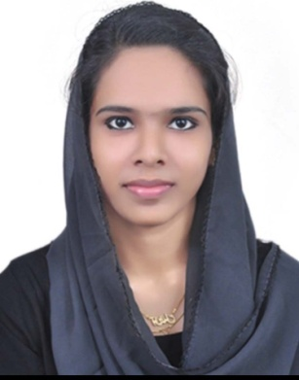**THOUFIYA MR**

Designation: Anesthesia technician

Contact : +971563394289

Email : mrthoufiya@gmail.com

**DHA ELIGIBLE**

**PROFESSIONAL OBJECTIVE**

To assists Anesthetist with modern Equipment’s in Multispecialty hospital in all the ways beneficial for the needed and to prove the knowledge and skill attained.

**EDUCATION**

* **Diploma in operation theatre and anesthesia technician**

(KERALA INSTITUTE OF MEDICAL SCIENCE)

Kerala paramedical council, Directorate of Medical education 2013-2016

**WORK EXPERIENCE**

* **Worked as an Anesthesia Technician in**

**LOTUS HOSPITAL, Bangalore**

(**4th November 2017 to 12th January 2020**)

* **Worked as an Anesthesia Technician in**

**KIMS HOSPITAL, Trivandrum**

**(01st March 2017 to 25th September 2017)**

**SKILLS AND RESPONSIBILITIES**

Checking and organizing Anesthesia Machines, other Machines,

Monitors and all Airway Equipment and Disposable.

**Assisting Anesthesiologist**

1. In **General,Sedation,Regional Anesthesia and MAC** in all kinds of Surgeries including Cardiac, Thoracic,vascular,liver and Renal transplant,Laproscopic,

Bariatric Urological, Orthopedic, Neuro, Pediatric, Gynechological, ENT, Ophthalmology surgeries.

1. In various **Procedure**s like Difficult intubation,Bronchoscopy,Ultrasound guided nerve blocks and vascular cannulation like arterial line, Central line, IABP, Labor Analgesia,Spinal,ABG,ACT Sampling, insertion of TEE Probe,Monitoring and Transferring of patients.

**HANDLING OF EQUIPMENTS**

Anesthesia Machine, Breathing circuits, Anesthesia monitor, Flexible Bronchoscope, Defibrillator, Syringe pump, Infusion pump, Suction apparatus, Pressure Monitoring transducers, Peripheral nerve stimulators, OT lights, Diathermy Machine.

**ADDITIONAL QUALIFICATION**

BLS and ACLS (Certified by AHA)

**PERSONAL DETAILS**

* Name : Thoufiya MR
* Date of birth : 5th October 1995
* Nationality : Indian
* Religion : Muslim
* Marital status : Married
* Languages known : English, Malayalam and Tamil
* Permanent address : SR House, Pothencode PO

Trivandrum, Kerala, India

* Passport no. : R9046783

**REFERENCES**

1 Dr.Shafi, senior consultant Anesthesiologist, Lotus hospital, Bangalore

Email:shafi0506@gmail.com

Contact: +917907007582

2 Dr.Bhadrinath N, Consultant anesthesiologist (Liver transplant anesthesia), KIMS Hospital Trivandrum

Email:bhadrinathn@gmail.com

Contact: +918129603634

**DECLARATION**

I THOUFIYA MR, Hereby declare that all Information Mentioned above is True to the best of my Knowledge and Belief.

**THOUFIYA M R**