**TAMPA ELVIS ANJEH OJAH**

**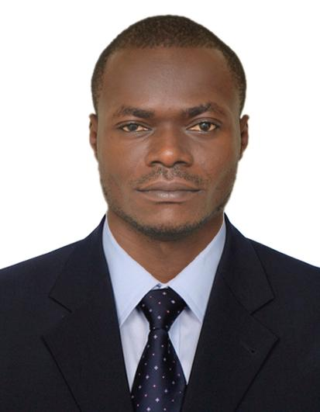 *REGISTERED NURSE***

**TELEPHONE: 0554898294**

**NATIONALITY: CAMEROONIAN**

**Email: tboyanje@gmail.com**

**SUMMARY**

A dedicated nurse in the service of humanity and quality healthcare. Seeking a position within hospital, clinic and/or homecare settings, permitting me contribute to delivering quality healthcare in respect of teamwork and assiduity. I may also be of use in health insurance and third party administrator corporations as a claims processor or customer service administrator.

**PROFESSIONAL EXPERIENCE**

**DOWNBEACH MEDICAL CENTRE- CAMEROON**

*Position:* Head Nurse

*Employment period:* August 2016 – November 2018

**Responsibilities:**

* Administered medications and pain management in accordance with care plan instructions
* Implemented patient care in accordance with established policies and procedures
* Monitored and communicated patient conditions using computerized documentation systems
* Delivered thorough patient evaluations, collecting and prioritizing data to effectively provide care for patients
* Assisted in developing care plans and appropriate medical attention, conferring with physicians
* Maintained patient records within the electronic medical record (EMR) system
* Performed comprehensive health assessment and health histories
* Involvement in mothers and child health (antenatal care, labor and delivery, postnatal care and neonatal care)
* Assures quality of care by adhering to therapeutic standards; measuring health outcomes against patient care goals and standards; making or recommending necessary adjustments; following hospital and nursing division's philosophies and standards of care set by state board of nursing, state nurse practice act, and other governing agency regulations.
* Resolves patient problems and needs by utilizing multidisciplinary team strategies.
* Protects patients and employees by adhering to infection-control policies and protocols, medication administration and storage procedures, and controlled substance regulations.

.**EDUCATIONAL PROFILE**

* Diploma in nursing 2013-2016

Languages

* **English prohificient**, speak , read and write **French prohificient** , speak, read and write