**UTHARA RAJAN N K**

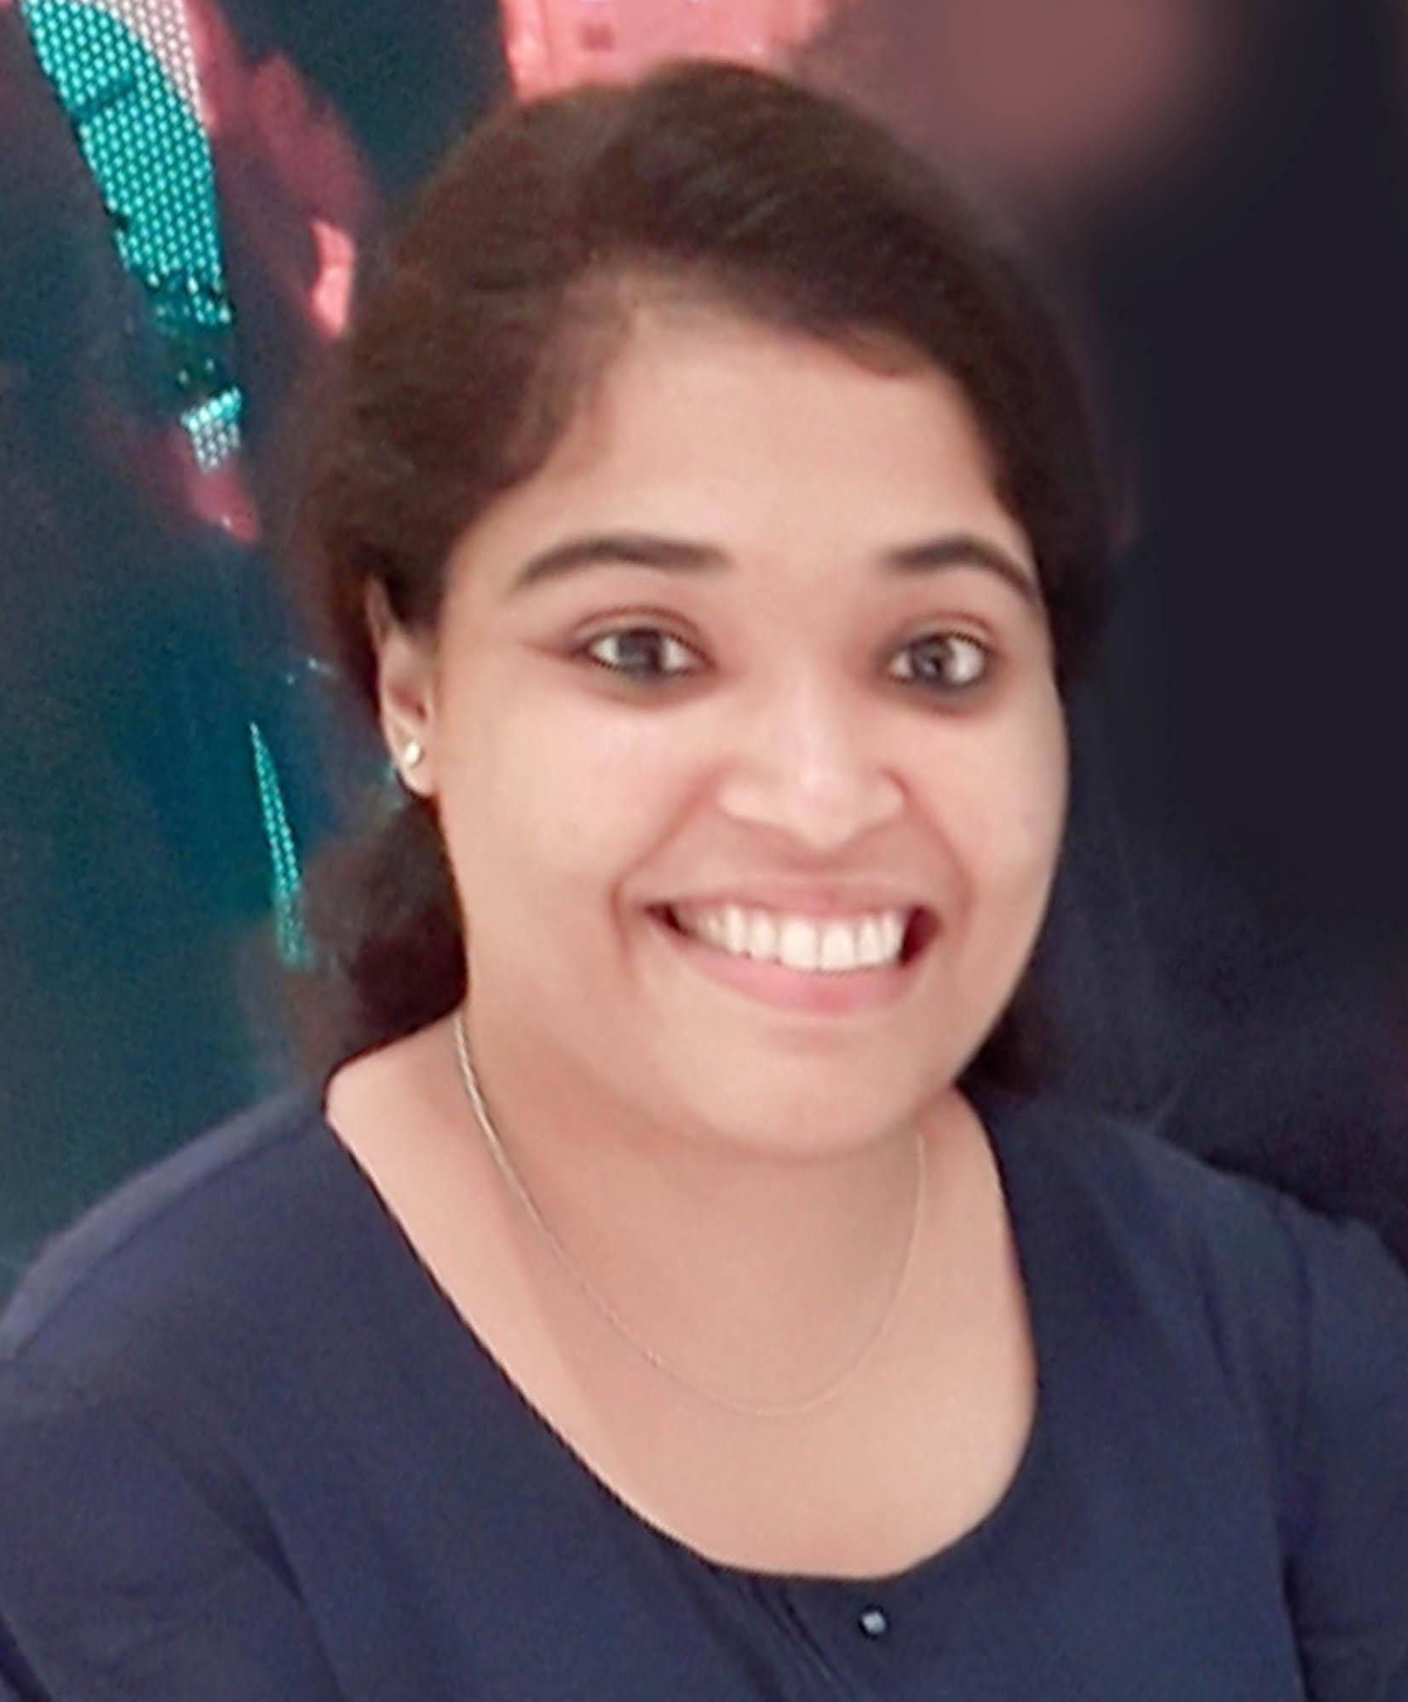

Mobile: +971 582420229

Email: [uthararajan123@gmail.com](mailto:uthararajannk@gmail.com)

Visa Status :Visit Visa

Valid Upto: September 2019

Seeking career opportunity with a progressive company that will help me utilize my skills and enrich my experience for my career growth and future advancement.

**Brief Overview**

* Currently working with Wenger and Watson Inc. as Talent Acquisition Consultant (2019)

Previously worked with

* Delivery Centric Technology Services Pvt. Ltd as Talent Acquisition Consultant 2016- 2018)
* Rivera Manpower Services as HR Recruiter (2015).
* Sree Narayana Vidya Mandir Senior Secondary CBSE School as a Counselor (2014-15), Kannur, Kerala.
* M.Sc Psychology (OB & HRD) completed from Central University of Karnataka.
* Professional with good communication and analytical skills and possess a flexible and detail oriented attitude.

**Professional Experience**

**February 2016 – 2018 Delivery Centric Technology Services Pvt. Ltd, Bangalore**

**Profile**: **Talent Acquisition Consultant**

**Skills:**

* Screening
* Recruiting
* Scheduling Interviews
* Follow ups
* Client handling
* Meeting clients
* Onboarding

**Roles and Responsibilities:**

* Responsible for full life cycle technical recruitment of IT professionals for Australian and Domestic market.
* Sourcing resumes through various mediums like job sites, networking sites, head hunting, Online resume mining references, advertisements & Internal Database.
* Screening and shortlisting resumes based on the client’s requirement.
* Interacting and Liasoning with the clients to get an understanding of their various requirements in order to provide optimum service
* Screening and shortlisting resumes based on the client’s requirement.
* Responsible for conducting initial assessments of candidate on communication, attitude and commitment.
* Scheduling interviews for shortlisted candidates in coordination with the clients.
* Keeping the candidates updated about the interview schedule and feedbacks.
* Bridging the gap between the Client & Candidate with respect to Compensation offered, Date of Joining and other related concerns.
* Perform reference checks and employment verification.
* Follow-up with candidates for Post-Employment Reference Checks, Notice Period Negotiations, etc. till joining.
* Dedication to follow-up the candidates and close the job offer.
* Post joining feedback from the clients and the candidates.
* Responsible for maintenance of candidate records.

**November 2015 –January 2016, Rivera Manpower Services, Bangalore**

**Profile: HR Recruiter (Non-IT Recruitment).**

**Skills:**

* Screening
* Recruiting
* Scheduling Interviews
* Follow ups

**Responsibilities:**

* Lead the full life cycle of recruitment for various openings on a monthly basis.
* Draft job descriptions, push them through all talent acquisition channels and coordinate candidate sourcing with the same.
* Screen candidates and conduct first round interviews to ensure their qualifications meet open positions
* Coordinate and organize in-person interview rounds.
* Build and maintain a strong network to source candidates from various channels including referrals.
* Effective convincing and negotiation skills to impress and attract top talent.
* Maintain recruitment related documents.

**October 2014 to March 2015, Sree Narayana Vidya Mandir Senior Secondary CBSE School, Kannur, Kerala**

**Profile: Counselor.**

* Conducting Life Skill Classes for Students (class 5thto 10th)
* Counseling

**Roles and Responsibilities:**

As a Counselor

* Counsel Students
* Liaise with Teachers and Parents
* Participate in Student Welfare and Learning Support Committees
* Evaluate and Improve the Counseling Program
* Refer students to external Counseling center

As a Life Skill Development Teacher

* Overseeing the implementation of literacy and math curricula.
* Reviewing lesson plans and creating “best practice” instructional strategies.
* Ensuring that each scholar meets their academic goals.
* Providing oversight, guidance, coaching and direction to fellow after school Tutors.
* Reviewing Edusoft data and utilizing it for instructional enhancement.
* Monitor scholars’ educational and social progress and making necessary recommendation for adjustments.
* Ensuring uniformity and timeliness of assessments and parent reporting.

**Internships:**

* Air Travel Enterprises (Trivandrum Head office and Calicut branch office) - Organizational Study.
* Western India Plywood Limited (Valapattanam, Kannur) on the topic, ‘The Effectiveness of Performance Appraisal’ in the month of March-April 2014.

**Core Competency**

* Good communication and interpersonal skills
* Execute my talents in an excellent manner
* Ability to handle pressure and to work with targets
* Hardworking and fast learner

**Technical Expertise**

* Windows All versions
* Certified in MS Office and Internet
* Basics in Statistical Package for the Social Sciences (SPSS)

**Achievements**

* Part of Organizing Committee of the National Conference held at H. H. Maharaja’s Women’s College, Trivandrum, (Kerala) in 2009 & 2012.
* Participated and won prizes in cultural and sports competitions in school and University.

**Areas of Interests**

* Human Resource Development and Management
* Recruitment
* Training
* Soft skill training

Personal Details:

* Nationality: Indian
* Father’s Name: Rajan K K
* Passport Number:M1728767
* Valid Upto: 25/08/2024