Anisha Mary Varghese

Staff Nurse

PROFESSIONAL SUMMARY

Certified DHA License holder and Staff Nurse offering 2.6 years of experience in nursing and healthcare. Expert in managing all aspects of patient care with hands-on experience in Medical Surgical Ward .

Registered Nurse *March* *2019-Feb* *2022*

**CONTACT**

+971 50 498 0597

**WORK** **HISTORY**

Dr. L.H. Hiranandani Hospital, Powai- Mumbai, India

Registered Nurse *August 2022 Till Date*

Noor Al Mamzar Medical Centre, Hor Al Anz- Diera, Dubai

Worked within interdisciplinary health care team to develop, implement an adjust patient care plans, individualizing strategies and methods to

improved health and meet recovery goals.

Delivered medications via Oral, IV and intramuscular injections, monitoring responses to address new concerns.

Notifies physicians accordingly and complete documentations in timely manner.

Educate patients and families on medical-surgical procedures, therapeu- tic regimens and pain management techniques.

Presents a professional image at all the times.

Performs tasks and duties within the scope of knowledge, skills and experiences required for the job and ask deemed competent.

Skilled with the procedures of Hijama, Botox, Filler, Liftera, Mesotherapy, and PRP

Bachelor of Science: Nursing

**EDUCATION**

Krishna Institute of Medical Science and Research Centre Maharashtra, INDIA

Higher Secondary: Science,

St.Theresas Bethany Convent - Kerala, INDIA

2019

*2015*

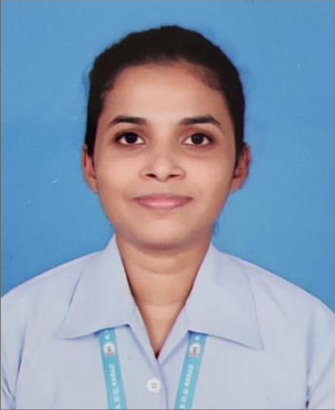

**+971** **504980597**

[anishamvarghese97@gmail.com](mailto:anishamvarghese97@gmail.com)

Deira, Dubai

**SKILLS**

* Medical clinical procedures comprehension
* Updating computer records
* Triaging patient concerns
* Critical care
* Admission and Discharge procedures
* Patient communication
* Patient care
* Nursing staff leadership
* Medication administration expert

**LANGUAGES**

English Advanced Hindi Advanced Malayalam Advanced Marathi

Intermediate

**ACHIEVEMENTS**

DHA ID- 119564

REF NO.- D001-2112-921913

DHA LICENCE NO- 22594739-001

**CERTIFICATIONS**

Advanced Cardiac Support as well as Basic Life Support (American Heart Association)

Critical Care Life Support

(DR. L.H. Hiranandani Hospital, Powai; Mumbai.)