

mmm

As a highly motivated and detail-oriented Office Administrator. I have developed a strong skill set in

managing administrative tasks, coordinating schedules, and providing excellent customer service. My

ability to prioritize tasks and work efficiently in a fast-paced environment has allowed me to

successfully handle multiple projects simultaneously. I am proficient in Microsoft Office Suite and

possess excellent communication and organizational skills. With a strong work ethic and a passion for

delivering exceptional results, I am confident in my ability to contribute to any organization.

Providing general support to office staff and management.

Drafting and editing correspondence and reports

Performing data entry and administrative tasks

Assisting with bookkeeping and financial record keeping

Ordering and maintaining office supplies and equipment

Maintaining financial records

Maintaining and organizing files and documents

Assist with the preparation of reports and presentations

Perform data entry and basic bookkeeping tasks

Manage and distribute incoming and outgoing mail

anjalirajeev666@gmail.com

Sharjah , United Arab Emirates

22436

+971505368664

**English**

**-**

Upper intermediate

(

B

2)

**Hindi**

**-**

Intermediate

(

B

1)

**malayalam**

**-**

Bilingual or Proficient

(

C

2)

**Tamil**

**-**

Elementary

(

2)

A

→





**Profile**

**Skills**

Knowledge of accounting principles

Knowledge of financial statements

Knowledge of accounting software

Expert in using word

knowledge in handling customer calls

Data entry operation

Familiarity with office procedures and protocols.

Ability to work independently and as part of a team

Experience in data entry and record keeping

Knowledge of basic accounting and bookkeeping principles

Proficient in Microsoft Office Suite (Word, Excel, PowerPoint, Outlook)

**Employment History**

**Office assistant**

Pazhayannur panchayath office | Thrissur, India

**Jan 2015 - Jun 2015**

**Internship**

**Office secretary**

Pazhayannur panchayath

| Thrissur , India

**Jan 2015 - Feb 2015**

Attended a on job training programme as a company secretary.

**Education**

**Bachelor Of Commerce**

Lakshmi Narayana college

| Kerala ,

India

**Calicut University -**

**Apr**

**2016**

Co-operation

**Typing & shorthand**

Government vocational higher

secondory school | Kerala , India

**Government Of Kerala -**

**Mar**

**2013**

**Languages**

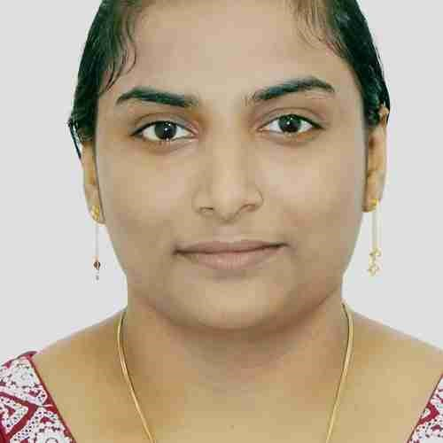

**Anjali**

**Rajeev**

Office administrator& medical coder



**Certifications**

Hindi PRATHAMIC

Shorthand&typing

On job training (office assistant)

**Accomplishments**

Giving a great presentation at work

mentoring a co-wo rker

Built and Maintained strong client relationship

Became a good Listener

Advised client on important issues like tax liabilities or fund security

**Visa status**

Husband Visa

**Marital Status**

Married

**Passport No**

P1904765

**Current Location**

Sharjah,Muweilah

Fire station road