**RESUME**

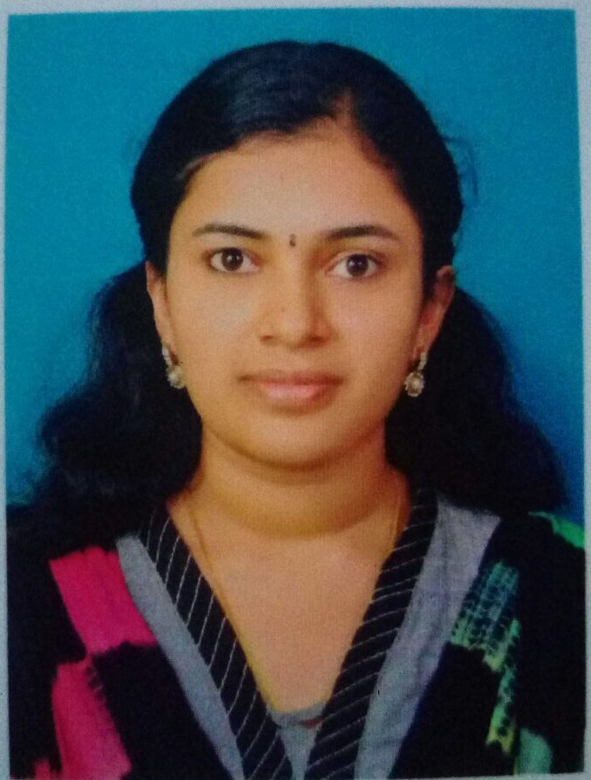

**Dr.ARYA CHANDRAN**

**Current Address**

**Fujairah**

**Mobile Number: 00971-503238078**

**Email Id**

[**aryachand555@gmail.com**](mailto:aryachand555@gmail.com)

**Personal Data**

**Date of Birth: 17.11.1992**

**Gender: Female**

**Marital Status: Married**

**Nationality: Indian**

**Passport Details**

**Date of Issue: 21.07.2016**

**Date of Expiry: 20.07.2026**

**Passport No: P1640580**

**Permanent Address**

**w/o Ghaharin jeeva**

**Manakkavillai,**

**Manalikarai (p.o)**

**Pin . 629164**

**CAREER OBJECTIVE**

Lookin Looking forward to build a dynamic career as Dental Surgeon in a reputed reputed organization, where I would be able to explore myself fully and apply apply the best dental practices to gain tremendous encroachment

in my professional career

**EDUCATIONAL PROFILE**

* Bachelor of Dental Surgery from The Tamilnadu DR. M.G.R MEDICAL UNIVERSITY 2010-2015

**LICENSES**

* **MOH Licensed : 170017 (Evaluation Certificate no)**

**WORKING EXPERIENCE**

* Designation: **House Surgeon**

Work span: 17-10-2014 to 31-10-2015

Company: Sree Mookambika Institute of Dental Science, Tamil Nadu

* Designation: **General Dentist**

Work Span: From 03-12-2016 to 30-09-2019

PRACTICED IN : **M.M. Dental Hospital**, THENI

Responsibilities Include

* Examining patients and interpreting radiographs and diagnostic tests
* Restoring carious, fractured or otherwise defective teeth
* Oral prophylaxis and cleaning procedures
* Tooth preparation to receive crown and bridges
* Tooth extraction, placing and removing sutures
* Fabrication of artificial dentures to replace missing teeth
* Teeth whitening and repairing fractured or chipped teeth
* Assisting senior dentist in periodontal flap surgeries
* Performing root canal treatments

Result analysis

Name of the Subject: **Dentistry**

Department: **Bachelor of Dental Surgery**

Results : 67%

**COMPUTER PROFICIENCY**

**MS-OFFICE**

**Microsoft Word**

**Microsoft Excel**

**Microsoft Power Point**

**APPLICATIONS**

**Internet**

**Email**

**Web updating**

**LANGUAGE**

**English**

**Malayalam**

**Tamil**

**Hindi**

**DECLARATION**

I hereby declare that the above statements are true to the best of my

Knowledge

Place: Fujairah Yours Sincerely

Date:  **ARYA CHANDRAN**