**RESUME**

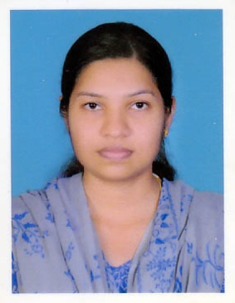

**Shobha Peter** Al Sidra Printing Press LLC

E-mail:zarrabiji@gmail.com Pb No:21874

Sharjah,UAE

Mob No:+971 559924187

# Educational Qualifications

* **Post Basic B.Sc Nursing** from Kerala University of Health Science, Kerala, India, in 2015
* **General Nursing and Midwifery Course from** Kerala Nurses andMidwives

Council, Kerala, India, in 2010

* **Class 12** from Board of Higher Secondary Examination, Kerala, India, in 2006
* **SSLC** from Board of Public Examination Kerala, India, In 2004

**REGISTRATIONS**

Sharjah MOH License No. T41706

Kerala nurses and Midwives council Registration No : 70749

**WORK EXPERIENCE**

* **AL KAMAL MEDICAL CENTER SHARJAH STARTED FROM 30.6.16**
* Al Kamal Medical Center for Obstetrics , Gynaecology and Paediatric patients
* Responsible for providing iv fluids , intra Mascular injections , subcutaneous injections ,
* and nebulization
* Responsible for maintaining Records and reports
* Assisted Procedure like high vaginal swab, pap smear and infant vaccination
* Completed the clinical assignments like Medical and surgical nursing, Pediatric nursing and maternity nursing.
* Participated and organized educational program.
* Completed one month clinical training in Mental health nursing at kuthiravattam Mental Hospital, Calicut, Kerala**.**
* Completed the assignments like Community health nursing, Administration, Education.
* Completed the dissertation entitled “Knowledge and practice of pregnant women regarding the use of electronic equipment with Non-ionizing radiation during pregnancy**”**
* **K.M.C.T Medical College Hospital, Calicut, Kerala(18.4.2010-15.10.2012)**
* Responsible for providing nursing service to person who required emergency care.
* Efficient on dealing with instrumental like defibrillator, AED, Cardiac monitors, Centralized oxygenand suction apparatus**.**
* Assisted in procedure like intubation, Incision and Drainage and wound dressing, ICD, POP application, BB splint and Thomas splint application**.**
* Taken charge of emergency department and assigned duties for nursing students.

**PARTICIPATION AND ACHIEVEMENT**

- Attended the continuing education Program on ACLS (Advanced

cardiovascular)(support) and BLS (basic Life Support)

* Attended the Continuing education program on ‘intensive respiratory nursing’

what in new.

* Organizer for the Educational program on ‘Molding Novice Nurses’
* Participant for the educational program on ‘Infection Control Nursing-An Update’
* Participant for the educational program on ‘Adult Emergency Medicine’

PERSONAL PROFILE

Husband Name : Biji K Thomas

Age, Date of Birth, Gender : 27, 25th November 1987, Female

Marital Status : Married

Nationality : Indian

Permanent address : Kalapurackal (H)

Ambalappuzha(P.O)

Alappuzha,Kerala

India

Passport No : j5805980 (valid up to 27/06/2021)

Issued Place : Cochin, Kerala

Languages Known : English, Malayalam, Hindi

DECLARATION

I hereby declare that all the information given is true and valid to the best of my knowledge.

Place: Alappuzha Signature

Date: SHOBHA PETER