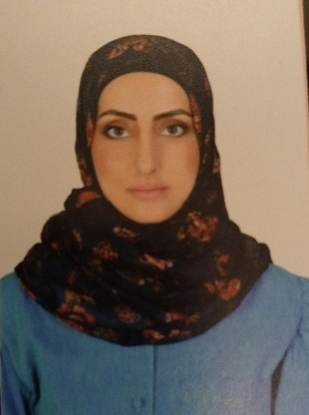***CV***

\****Personal data*:**

name: racha dib

Gender: female

nationality: syrian

Job: ophthalmologist

marital status: married

D.O.B:28/11/1983

Phone:00971 545152601

Email: [deebrasha558@gmail.com](mailto:deebrasha558@gmail.com)

Adress: UAE , Sharjah

Languages:

1- Arabic.

2_ English.

3_ Persian

Education:

1. Bachelor s degree of general medicine 2010 from Iran university of medical sciences.
2. Master degree of ophthalmology 2015 from ministry of health syria.

‏

***Academic and professional licenses****:*

*passed the cornea and anterior chamber course for 3y in Tehran Iran 2016-2019.

*‏passed the ophthalmology board examination of Syria in November 2015.

*Passed the general medicine examination in Iran university of medical sciences 2010.

*M.O.h/syrialicence  2011

*\** ***Work skills:***

       ‏

**1_High experience in clinical skills:**

*excellent communication with patients and clinical staff ,reliability , hardworking

accurancy in examination and ttreatment.

 *examination of

lid, conj,sclera,cornea,AC, lens,iris,vitreous,angle by three mirror lens, funds by direct and indirect opthalmoscope , evaluation of macula and vessels and optic nerve .

*expert in lacrimal duct probing and obstruction evaluation.

*paraclinic skills:

1_ Ascan

2_Bscan To R/O retinal detachment and iris- choroid- retinal tumor.

3_evaluation of Oct for macular diseases such as CME_CSR_Macular hole and others.

4_ evaluation of NFL Oct.

5_evaluation of topography for refractive surgery and KC and other corneal diseases.

6_evaluation of visual field for glaucoma and scotoma.

7_evaluation of FFA for different diseases specially diabetic retinopathy.

8_expert in photogoagulation of retin Argon laser (prp,focal,grid).

9_expert in yag laser for PCO.

10_expert in yag laser to do PI to treatment acute closure glaucoma and prophylaxy of IOP elevation in shallowAC and before some phakic refractive surgeries.

***2_High experience in surgical skills:***

****minor surgery.

***Ptergium surgery with graft.

***Cataract surgery. (phaco)and iol implantation.

***Glaucoma surgery( Trabx,ahmed valve)

***Phaco+trabx

***Phaco+ahmed valve.

***PKp.

***PKP+ cataract.

***Blepharoplasty, upper and lower lid

***Horizontal strabismus.

***Ant. Vitrectomy.

***Refractive surgery(PRK,Laisk,femtolaisk).

***Phakic surgery([ICL.toric](http://icl.toric) [ICL.artisan](http://icl.artisan)).

***CXL.

Details of experience:

*Working at the private clinic in Latakia city ( November 2015 _ june 2016).

*Working at basir eye center iran (june 2016_ December 2019)

*working at the private clinic in Damascus Syria as a maneger and an ophthalmologist (December 2019 _April2021)

*Working at health hub alfuttaim from August 2021 to September 2022.

* Working at Emirates European hospital Sharjah October 2022 up till now.

**Additional details:**

**Doing more than 100 surgery (phaco , intra vitreous inj ,eye trauma surgery)from November 2022 up till now**