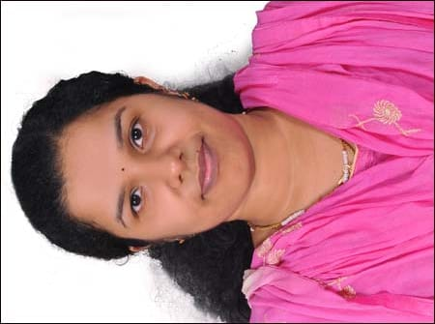

**JINTA VARGHESE**

**Medical coder/Nurse**

[jintav@gmail.com](mailto:jintav@gmail.com)

andreasameliya@gmail.com

+971552550452 (UAE)

+971524011841

Spell Check

RESUME SECTIONS

(U Heading

= Professional

Summary

i= Skills

£*Work History

Education

+ Add a section

A Download

VARGHESE

**WORK HISTORY**

**LLH Hospital Abu Dhabi - Registered Nurse**

**Abu Dhabi, UAE** • **10/2012 - 06/2015**

* Worked closely with patients to coordinate realistic goals and   
  strategies for care.
* Provided quality care for patients with varied conditions, including heart failure, end-stage renal disease and coronary artery disease.
* Managed the patient discharge and admissions process.
* Performed physical assessments, ordered preliminary tests and charted all interactions.
* Coached nurses in proper execution of pain assessments.
* Assisted over 100 patients per day while planning, monitoring and
* Evaluating interdisciplinary care.
* Advocated for patients by communicating their care preferences to practitioners, ensuring interventions met their goals for treatment and identifying insurance coverage.
* Reviewed and revised patient care plans.
* Reported findings to quality departments after conducting routine   
  restraint audits to ensure adherence to guidelines.
* Participated in unit-based Quality Assurance Program.
* Managed detailed patient records, including patient histories, vitals and assessments.
* Acted as the first point of contact for evacuations, admissions and transfers during emergency situations.

**Indraprastha Apollo Hospital - Registered Nurse**

**New Delhi, DL •** **10/2009 - 05/2011**

* Completed head-to –toe physical assessments and interpreted diagnostic tests, leveraging information to face Providing Comprehensive Health Care to Clients
* Monitoring and evaluating Nursing Process after Carrying out   
  essential Health Care.
* Assisting the Medical Officers in Performing Diagnostic and   
  Therapeutic procedures
* Maintain records
* Supervise and teach students in clinical fields.
* Demonstrate standards of nursing practice.
* Participate in student welfare activities.
* Maintaining a good workmanship and individuality in all my work.
* Maintain good IPR with Colleagues, health personals, and clients. ilitate care planning, implementation and management.

**PROFESSIONAL SUMMARY**  
Hard working and fully certified Medical Coding Specialist has a full understanding of ICD-10-CM and CPT coding procedures. Excellent data entry skills allows for accurate coding of medical information and provided care. Has an Associate's Degree in Nursing and Coding Certification as a Medical Coder.

**SKILLS**

* Data management
* Report writinng
* Team leadership
* Data entry
* Risk management processes and   
  analysis
* Self-motivated
* Interpersonal and written communication.
* Clerical support
* Extremely organized
* Project Management
* Code validation skills

**EDUCATION**

* **B.Sc. in Nursing**

**BLDEA College Of Nursing   
Vijayapura, KA • 2008.**

* **Professional Medical coding and advanced billing.**

**Transzorse solutions Kottayam KL 2018**

**LICENSURE**

* **Licensed registered Nurse in India**
* **Licensed Registered Nurse by HAAD**

**CERTIFICATION.**

* **Certified medical coder by American Academy of Professional coders.**

**VISA STATUS**

* **Husband visa**