**RESUME**

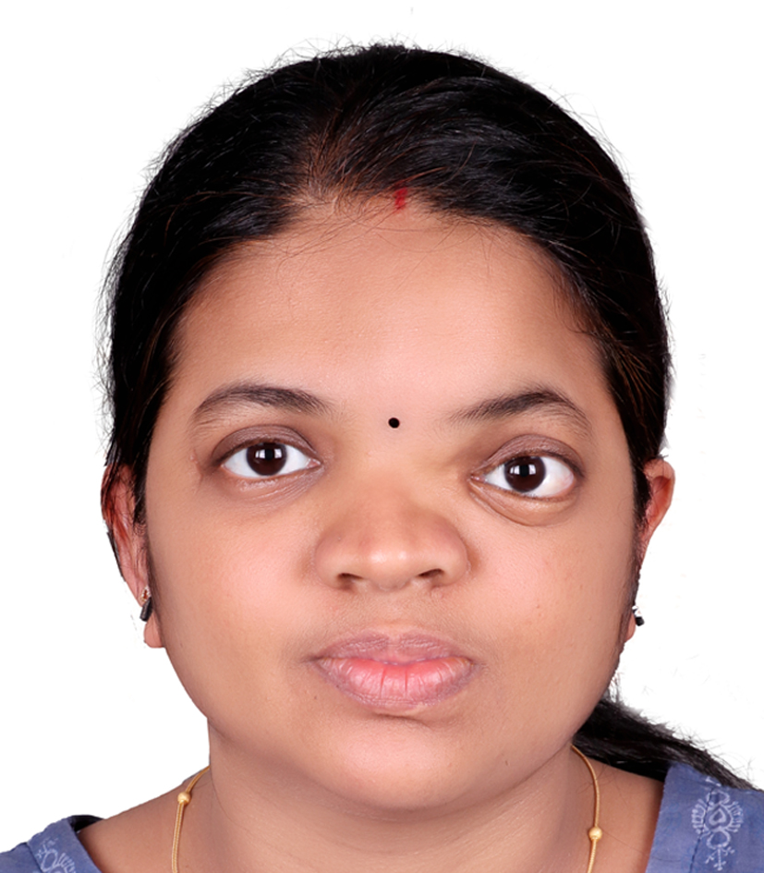

*Sony A S*

*Flat no3693,Room101*

*Muwailih, sharjha*

*EMAIL:sonyas220689@gmail.com*

*CONTACT NO :0559028644*

**EDUCATIONAL QUALIFICATION:**

1. **ACADEMIC**

|  |  |  |  |
| --- | --- | --- | --- |
| **Name of the Course** | **Name of the School/College** | **Year of Pass out** | **% Secured** |
| S.S.L.C/ Govt. of Kerala | St.Paul’s C.E.H.S.S, Kuriachira, Thrissur | 2005 | 81.4**%** |
| Higher Secondary Examination Board, Kerala | G.H.S.S, Nandikkara | 2007 | 72.6 **%** |

1. **PROFESSIONAL QUALIFICATION**

|  |  |  |  |
| --- | --- | --- | --- |
| **Name of the Course** | **Name of the School** | **Period of Course** | **% Secured** |
| B sc Nursing | Jubilee Mission College of Nursing affiliated by Kerala nursing council and  Indian nursing council | 2008-2012 | 58.7% |
| 1st Year (2008-09) | 61.9 **%** |
| 2nd Year (2009-10) | 56.3**%** |
| 3rd Year (2010-11) | 59.7 **%** |
| 4th Year (2011-12) | 56.6% |

**ADDITIONAL INFORMATION**

Professional registration : Registered under Kerala Nursing

Council No: 59155

Descriptive Studies done : Assessment of Knowledge and Practice

Of Staff Nurse Regarding care of

Preterm Baby in Neonatal ICU & Labour

Room in Jubilee Mission Medical College & Research Institute, Thrissur

Kerala.

**CO-CURICULAR ACTIVITIES**:

Actively participated in community awareness programs and basic knowledge in computer and a member of student nurses association and Trained Nurses Association of India.

**WORK EXPERIENCE:**

|  |  |  |  |  |
| --- | --- | --- | --- | --- |
| **Sr. No.** | **Hospital** | **Position** | **Duration** | **Area** |
| 1 | Deenanath Mangeshkar  Hospital and Research  Centre, Pune | Staff  Nurse | Joined on 20/9/2013 till 7/10/2015 | ICU |
| 2 | Elite mission hospital  Thrissur kerala | Staff nurse | Joined on  1/12/2015and till15/07/2017 | ICU |
| 3 | Aster hospital, qusais  Aster hospital, sonapur | Registered nurse | Joined on 13/9/2020till 31/1/2021  1/11/2021 till still working | ICU  Emergency |

**Modern Equipments Handled in Intensive Care Unit**

* Ventilator.
* Breathline CPAP,Bottle CPAP.
* Standardized Monitor.
* Pulse oxymeter.
* Arterial Blood Gas and Electrolytes Machine.
* NO, and O2 analyzer.
* Infusion pumps.
* Syringe Pumps.
* Glucometer.
* ECG Machine.
* Defibrillator.
* Nebulizers.
* BP Apparatus (Manual and Electronic).
* NO and O2 Cylinder.
* Transducer.
* Warmer Facilities.

**Excellent Knowledge of basic nursing functions and skills trained to perform the following procedure functions:**

* Nursing the patient in Ventilator, CPAP etc.
* Admission, Shifting and discharge procedure.
* Vital signs
* Cardio pulmonary resuscitation.
* Administration of medicine (Oral and Injections).
* Oxygen Therapy.
* ECG.
* Ryles tube insertion.
* Ryles tube feeding.
* Intracath insertion.
* Urinary Catheterization.
* ABG and VBG Collection.
* Blood Collection with vaccutainer.
* Suctioning of patients on invasive ventilators.
* Colostomy care.
* TPN.
* Peritoneal Dialysis.
* Transducing arterial lines.

**Capable and competent in assisting the following procedures:**

* Endotracheal intubation and extubation.
* Defibrillation.
* Central line placement and arterial line insertion.
* Peripherally inserted central catheterization (PICC).
* Insertion and removal of intercostal drains.
* Insertion of haemodialysis catheter and peritoneal dialysis catheter, insertion of suprapubic catheter.
* Lumbar puncture.
* Bone marrow aspiration.
* Pleural tapping and ascitic tapping.

**Administrative Responsibilities:**

* Co ordination of nursing activities.
* Assisting and delegating duties and responsibilities.
* Orientation of nursing students and new staffs.
* Supervision of junior staff nursing aids and domestic staffs.
* Storing of dangerous drugs.
* Inventories and recording.

**Employment History:**

**Job title experience:**

1. Deenanath Mangeshkar Hospital and Research Centre, Pune, India.

Bedcapacity **:** 705 Beds

1. Elite mission hospital,thrissur,kerala

Bed capacity : 350 beds

**PERSONAL DETAILS**

Name : SONY A S

Age &Date of birth: 33,22 jun2 1989

Nationality : Indian

Marital status : married

**PASSPORT DETAILS**

Pasport No. : L1391736

Place of issue : COCHIN

Date of issue : 29/04/2013

Date of expiry : 28/04/2023

**Declaration:**

I solemnly declare that the above statement are entrusted and true to the best of my knowledge and belief.

**Place :sharjha** Sony.A.S

**Date : 22-10-2022**