**DR RANJEET KUMAR**

**Gp** **Dentist**

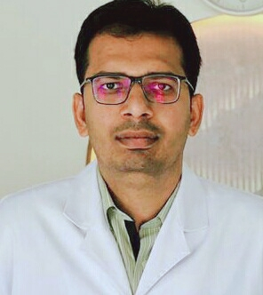

**Address:**

**Sanaiya, Alain**

**Mobile & Whatsapp:**

**+971567027006**

**Email:**

**drranjeetkumar@yahoo.com**

**Date of Birth: 22-09-1988**

**Gender:** **Male**

**Marital status:** **Single**

**Passport Number**: **AQ4221452**

**Languages Known:** **English, Urdu, Hindi, Arabic, Punjabi and Sindhi** **Nationality:** **Pakistani**

**REFERENCE:** **Will be provided upon request**.

**SUMMARY**

**Ambitious qualified dentist with excellent organizational and Interpersonal**

**Skills keen to secure a position with dynamic and Progressive dental practice.**

**Ideal candidate for position requiring Drive, initiative, responsibility & challenge**

**CORE COMPETENCIES**

**Periodontal surgeries, Esthetic and cosmetic dentistry, dental treatment of**

**Medically compromised patients, clinical diagnosis and treatment planning,**

**General dentistry, emergency dental care and dental ethics.**

**EDUCATION**

**BACHLOR OF DENTAL SURGERY (BDS) 2007-12**

**Liaquat University Of Medical And Health Sciences Jamshoro, Pakistan**

**D**

**DIPLOMA IN IMPLANTOLOGY (One Year Dip-Implantology) 2016-17**

**Mehran Institute of Continuing Dental Education, KARACHI**

**Callaborated with ' U'R SMILE (ENGLAND**)

**PROFESSIONAL EXPERIENCE (7 YEARS CLINICAL EXP:)**

**Gp Dentist**

**Alostora Medical Centre, Al Ain, United Arab Emirates May2019 - Present**

**Gp Dentist**

**Pride Medical Centre, Al Ain, United Arab Emirates Nov 2017 - Mar 2019**

**Dental Surgeon**

**Elite Dental Clinic, DHA Phase-2, Karachi, Pakistan April 2016 - Nov 2017**

**Dental Surgeon**

**Sufi Rohal Dental Clinic, Mirpur Mathelo, Pakistan April 2014 - Mar2016**

**Dental Surgeon**

**Liaquat University Hospital, Hyderabad, Pakistan** **April2013 - Mar2014**

**SKILLS**

**DENTURES, CROWNS AND BRIDGES**

**SILVER & TOOTH COLORED RESTORORATIONS**

**treatment, ROOT CANAL TREATMENT**

**SIMPLE AND IMPACTED TOOTH EXTRACTIONS**

**BLEACHING AND VENEERS**

**PROFESSIONAL LICENSE**

**Health Authority Abu Dhabi (HAAD) Nov2017 - Nov 2021**

**Pakistan Medical and Dental Council (PMDC)**  **March2013 – Dec2023**