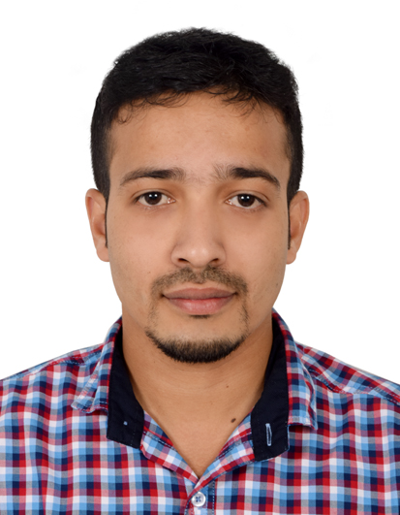

**JAMSHEER PALAYAKKODAN**

**DOH Licensed RADIOGRAPHER**

***MRI, CT SCAN & X-RAY* (9 years 8 months experience)**

**DOH** License No. **: GT18941**

**MOH** Evaluation No. **: 171735**

Visa status **: Employment visa**

**OBJECTIVE**

To achieve professional excellence with intellectual abilities, which gives me scope to apply knowledge and skills in round Radiological Diagnosis services that dynamically work towards growth of organization.

**PROFESSIONAL EXPERIENCE**

* Worked as Radiographer in Department of Radiology at **MES Medical College & Hospital**, Malappuram, Kerala from 1st January 2010 to 8th January 2016.
* Working as Radiographer in Department of Radiology at **Open MRI For Spine Surgery**, Abu Dhabi, UAE since 13th February 2016

**PROFESSIONAL REGISTRATION**

* Registered at Kerala paramedical council, govt. of Kerala (reg no: 166/RTn/11.)
* Life time membership in Indian Association Of Radiological Technologists (reg no: LM2291)

**PROFESSIONAL ACHIEVEMENTS**

* **DOH** licensed.
* **MOH** evaluated.
* **CMEs** on various topics.
* **BLS** certified.

**EDUCATION**

**Professional Education**

* **Diploma in** **Radiological Technology(DRT)** from AL SHIFA College of Paramedical Sciences, Malappuram affiliated by Directorate of Medical Education (DME, Govt. of Kerala), Trivandrum (2007-2009) Reg.no:486
* **Bachelor of Science in Medical Imaging Technology(BScMIT)**(Distance Education)from Thoppil Institute of Science & Technology, Trissur, Kerala under Sikkim Manipal University. Reg.no: 681120638

**School Education**

* Higher Secondary from Govt. Higher Secondary School, Pandikkad, Malappuram, Kerala, under Board of Higher Secondary Examination, (Govt. of Kerala), Reg. No: 3244844.
* SSLC from Darul Falah English School, Poopalam, Perinthalmanna, Kerala, affliated to Central Board of Secondary Education *Reg. no: 4139628*

**PROFESSIONAL SUMMARY**

* **MRI Scan**:1.5T MRI scan with routine spine studies, musculo-skeletal studies, cerebral, neck, aortic, renal & peripheral angiographies, MRCP, Urography, fistulography, sinusography & contrast studies.
* **CT Scan**: Spiral CT of routine and emergency cases, retrospective reconstruction of bones, volume rendering processing such as 3D reconstruction and special procedures like angiograms, CT guided Biopsy & Cisternography.
* **X-RAY** : Better knowledge in routine x rays, fluoroscopic procedures such as Intra Venous Urography(IVU), Micturating Cysto Urethrography(MCU), RGU, sialogram, fistulogram and barium studies(swallow, meal, BMFT, enema etc.). Conventional Radiography, Computed Radiography & Digital Radiography.
* Has ability to operate technologically advanced equipments.
* Take all precautions for radiation protection of the patient, co-workers, general public and self.
* Preventive maintenance of the machines and its accessories

**EQUIPMENTS HANDLED**

* **X ray machines**
* 800 mA with digital fluoroscopy
* 500 mA (GE)
* 300 mA (GE, Siemens)
* 300mA(Siemens)
* **Others**
* Digital Radiography: Axiom Aristos VX (Siemens)
* Computed Radiography: Carestream
* Automatic Film Processing
* Dental X-ray Machine: KODAK
* **MRI Scan**
* 1.5T Siemens Magnetom-Avanto
* 0.35T Magnetom C
* **CT Scan**
* High speed dual slice(GE)
* SIEMENS Somatom Definition AS128 slice
* **Portable Machines**
* 100mA (Vision, Meditronics)
* 60 mA (GE, Allengers, Adonis)

**REGISTRATION DETAILS**

* Registered at Kerala paramedical council, govt. of Kerala (reg no: 166/RTn/11)

**PASSPORT DETAILS**

* Passport Number : J6246255
* Date of issue : 25/02/2011
* Date of Expiry : 24/02/2021
* Place of issue : Malappuram

**LANGUAGE PROFICIENCY**

* English, Malayalam (Speak)
* Arabic, Hindi (Read & write)

PERSONAL DETAILS

* Date of Birth : 31 Oct 1987
* Marital status : Married
* Father’s Name : Moideen Kutty
* Mother’s Name : Fathima
* Nationality : Indian
* Religion : Islam

**REFERENCES**

1. **Dr. EMAN ABDELRAZEK MOHAMED,** Specialist Diagnostic Radiology

Open MRI for Spine Surgery, Abu Dhabi, UAE

PO Box: 47448, Villa 66, Al Karama st. 14

Tel: +971554396338 (mob), +97124496613(office)

1. **Dr. SHAMEEM AHAMMED MD,** Radiologist, Asst. Prof.

MES Medical College Hospital, Perinthalmanna

Tel: +919495137038 (Mob), +914933 298 476(Office)

1. **Mr. LUKMAN,** Administrative Officer

MES Medical College Hospital, Perinthalmanna

Tel: +919895185437 (Mob), +914933 298 300 (Office)

**DECLARATION**

I hereby declare that all the statements are true and correct to the best of my

Knowledge and belief.

Abu Dhabi

23/10/2019 **JAMSHEER PALAYAKKODAN**