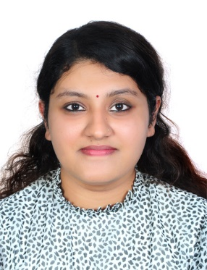

**LIJU** SARA MATHEW

lijusarah97@gmail.com Dubai 0561865583

# SUMMARY

Skilled PHP Developer with around 2 years’ worth of expertise in developing and maintaining complex web applications and e-commerce websites. Proficient in custom CMS solutions, third-party API integrations, and optimizing systems for scalability and performance. Self-motivated individual with the passion and drive to take ownership of new tasks and accomplish them. Active listener with exceptional communication skills willing to understand the situation and provide a logical and creative solution.

# SKILLS

* PHP development
* Codeignitier framework
* Digital Marketing
* Seo
* Blog Optimization
* MySQL
* HTML5/CSS3
* JavaScript
* jQuery
* AJAX
* Git version control
* MVC architecture
* Object-Oriented Programming (OOP)
* Custom CMS development
* CRM system development
* Responsive web design
* Website optimization
* Teamwork and communication
* Front-end collaboration
* Third-party API integration
* Scalability and performance optimization
* Problem-solving
* Collaboration

# EXPERIENCE

## PHP Developer

**1.Igen Software, Trivandrum**

**2.Nesote Technology,Infopark**

**Digital Marketing**

1. **Vintbit Info Digital solutions**

# EDUCATION

## Undergraduate Degree *2015 - 2019*

Bachelor of Technology in Computer Science

## Musaliar College of Engineering and Technology, Kerala

## Senior School *2013 - 2015*

**Gulf Model School, UAE**

# LANGUAGES

English Malayalam

# 

# HOBBIES

     Hindi         

Art, Cooking, Gardening, Travelling

# DECLARATION

I do hereby declare that above furnished information is true to the best of my knowledge and belief and I bear the responsibility for the correctness of the above-mentioned particulars.