**RESUME**

**Jijina Janeesh** 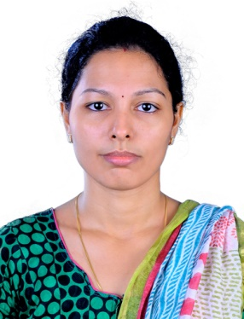

Email: [jijina00@gmail.com](mailto:jijina00@gmail.com)

Mobile No:+971561700649

Location: Sharjah

**OBJECTIVE**

I look forward to associate myself with an organization, where there is an opportunity to share, contribute and update my knowledge for development of the organization served.

**EDUCATIONAL QUALIFICATION**

* **MSc** *(Specialization in* ***Hospital Administration***) from Bharathiar university

( Coimbatore) in 2011 with **First class.**

* **BSc** (*in* ***Biotechnology*)** from Kannur University (Govt of Kerala) in 2009 with **First class.**

**KEY STRENGTH**

* Excellent administrative and organizational experience.
* Exceptional versatility and adaptability.
* Dedication and drive as a hard-working individual.
* Ability to manage multiple tasks in a pressured environment
* Independent handling of internal correspondence

**TECHNICAL SKILLS**

* Diploma in Medical Records Management
* Productivity Tool : MS Office, Windows

**WORK EXPERIENCE**

**Co-operative Hospital, Payyanur,Kerala**

***Role : Administration Executive***

***Period: 01/09/2011 to 31/08/2013***

***: 05/02/2020 to 25/08/2021***

***Responsibilities –***

Perform the duties assigned, from time to time

* Manage front office
* Updating medical history, transcribe treatment notes, arrange for patient hospitalization
* Process insurance forms
* Completing and submitting insurances claims
* Answering telephones, scheduling appointments, managing e-mail inquiries
* Maintain all record of the patients
* Preparing correspondence between medical providers and their patients
* Responsible for ensuring and maintaining strict secrecy of all information regarding the patient medical records

**PERSONAL DETAILS**

* Date of Birth : 17.03.1989
* Sex : Female
* Marital Status : Married
* Nationality : Indian
* Passport No : M0684676
* Languages Known : English , Malayalam, Hindi

**Declaration:**

I hereby sincerely and solemnly affirm that the above stated informations are true to the best of my knowledge and I assure you to give the best of mine.

**JIJINA JANEESH**