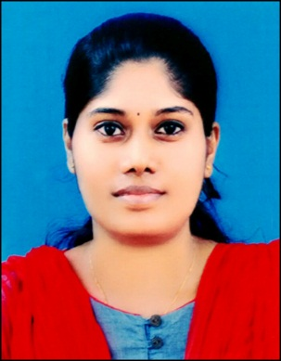  RASMI R NAIR  Rasmiramachandran45@gamail.com  Address:  Al Quasis, Near Sahara MalI  Dubai  Passport No : L2931205  Mobile : 0555421162  Visa : Husband Visa  Personal Profile  Date of Birth : 15-03-1990  Gender : Female  Marital Status : Married  Blood Group : B⁺  Nationality : India  Interests and Hobbies  - Music  - Travelling  - Drawing  - Writing  Linguistic Abilities  Languages:  English  - Speaking  - Writing  - Reading  Malayalam  - Speaking  - Writing  - Reading | CURRICULUM VITAE  CAREER OBJECTIVE  “Keen to support the growth and profitability of an organization that  provides challenges, encourages advancements and working towards  achievements. Seek relevant and challenging position in an enabling  environment where my current qualifications and abilities would be an  asset to the organization.”  ACADEMIC RECORD  Course University/ Board Year of Passing Percentage  MBA-HCS Sikkim Manipal University 2016 70%  BCA C M J University 2012 64.71%  Plus Two (Science) Kerala (HSE) 2008 66.6%  SSLC Kerala 2006 70%  OTHER COURSE  MCITP (Microsoft Certified IT Professionals) in IIJT  PROJECTS  - DEGREE PROJECT:  Access Control System using RFID Technology, Ernakulam  - MBA PROJECT:  A Study on Bio-Medical Waste Management in Hospital, KIMS Hospital Ernakulam  SEMINARS OR ACTIVITIES PARTICIPATED  - Attended two day seminar on the topics ‘Share Market’, ‘Quality assurance in Health care’, ‘Service Marketing’ at Muthoot college of Allied Health Science and Management Studies on 22nd and 23rd December 2014.  ASSETS  - Good communication skills.  - Quick learning ability.  - Can perform multitask.  - Leadership Qualities.  - Computer Skills (Microsoft word, Excel, Power point)  INTERESTED AREAS  - PRO  - Admin. Executive  - HR Executive  - Insurance Department  - Quality Department  - Inventory Department  EXPERIENCE  - 6-month experience at Reliance BPO Private Limited in Chennai.  - 1-year experience as Office Secretary at Mount Zion Medical College, Adoor in the department of Health Care Insurance (R.S.B.Y)  - 2-year experience as HR Assistant at Mount Zion Medical College.  DECLARATION  I declare that the information and the facts stated here in the above are  true and correct to the best of knowledge and belief. I am sure that I will  take responsibility of my job and do my best of my job to all my superiors  Date:  Place: RASMI R NAIR

