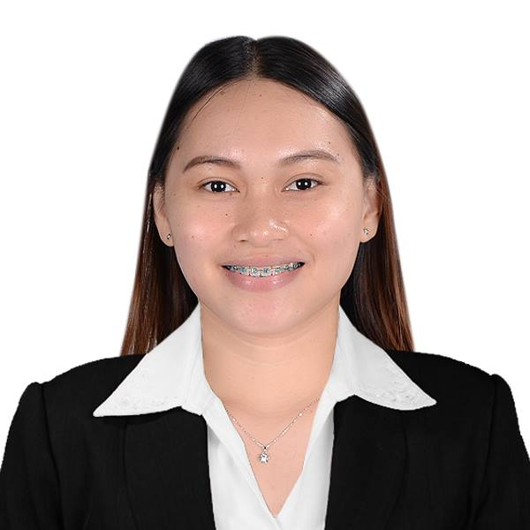

SHEENA BIANCA ESTRERA BANUAG

ASCP EXEMPTED DATAFLOW

Registered Medical Technologist

[sheenabiancabanuag@yahoo.com.ph](mailto:sheenabiancabanuag@yahoo.com.ph)

+971509468148

QUALIFICATIONS

* IMLS (ASCPi) (License No. 7923)
* ASCP exempted Dataflow
* Philippine Medical Laboratory Scientist (License No. 0076649)
* Bachelor of Medical Laboratory Science Graduate

CLINICAL EXPERIENCES

1. June 2017 – February 2019

Company: **Dominican Hospital, Inc.**

Location: Quezon Avenue, Digos City, Davao del Sur,

Philippines

Nature of the Company: Primary Healthcare Facility (50 bed capacity)

Designation: Staff Medical Technologist (Generalist)

Job Description

* Machines handled
  + Serology Section
* Finecare Wondfo
* Beckman Coulter Access Immunoassay System
  + Hematology Section
    - Beckman Coulter ACY DIFF Hematology Analyzer
* Mindray BC-3200 Hematology Analyzer
* Mindray BC-5180 Hematology Analyzer
* Olympus CXZZLED Microscope
* Olympus CX22LED Microscope
  + Blood Banking Station
* DIGISYSTEM Waterbath
* Biobase Blood bank refrigerator
  + Chemistry Section
* COBAS C111 (Roche)
* Instrumentation LAB – ILAB 300
* Roche 9180 Electrolyte Analyzer
* Easylyte MEDICA
  + Bacteriology Section
* Biobase Safety Cabinet
* Biobase Heated Incubators
* Fargo Hot Plate
* Biobase Oven
* JIBIMED Vertical Sterilizer (Autoclave)
* Shimadzu Digital Weighing Scale
* Main responsibilities covers routine and general laboratory works for the following sections: Clinical Chemistry, Hematology, Immunohematology, Coagulation, Immunology, General Serology, Microbiology and Clinical Microscopy.
* Perform manual crossmatching.
* Perform manual urinalysis and fecalysis.

2. November 2016 – May 2017

Company: **Cotabato Regional and Medical Center**

Location: Sinsuat Avenue, Cotabato City, Philippines

Nature of the Company: Tertiary Healthcare Facility (ISO accredited)

(400 bed capacity)

Designation: Staff Medical Technologist (Phlebotomist)

Job Description

* Machines handled
  + CELL-DYN Ruby Hematology Analyzer (Abbott)
  + IL ACL 7000 Coagulation Analyzer
  + Olympus CX22LED Microscope
* Collect blood samples from in-patient and out-patient.
* Performs phlebotomy such as venipuncture using different kinds of method: vacutainer, syringe, butterfly and capillary puncture. Able to handle at least 100 patients in an eight - hour shift.
* Runs control every morning shift.
* Process and examine samples for clinical morphologic and laboratory disorders of blood.
* Perform manual and automated procedures in hematology.
* Performs blood typing.
* Peripheral Blood Smear Preparation.

SEMINARS/TRAININGS

**12th PAMET Mindanao Regional Conference**

Philippine Association of Medical Technologists

August 24-26, 2018

**Biological Risk Assessment and Migitation**

Philippine Association of Medical Technologists

August 24, 2018

**Philippine Voluntary Blood Services Program, Transfusion Transmissible Infections and the Importance of Donor Recruitment, Selection, Counseling and Donor care**

Philippine Association of Medical Technologists

July 7, 2018

**Newborn Screening Training**

Department of Health Region 11

May 31 – June 1, 2018

**Understanding Errors in Analytical Performance**

Philippine Association of Medical Technologists

April 28, 2018

**Quality Improvement Training and Workshop for Clinical Hematology**

Philippine Association of Medical Technologists

July 22, 2017

REFERENCE

**Fraulein Rozel H. Habaradas, RMT**

Chief Medical Technologist

Dominican Hospital, Inc.

**Venus S. Mendoza, RMT**

Chief Medical Technologist V

Cotabato Regional and Medical Center

PERSONAL INFORMATION

Date of Birth: October 17, 1995

Age: 23 y/o

Nationality: Filipino

Religion: Roman Catholic

Visa Status: TOURIST