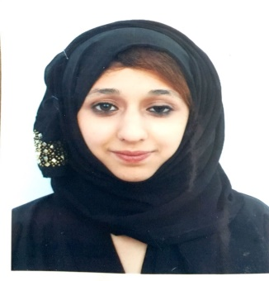  Contact Information  Pakistan, Rawalpindi   +971505955410  Zainab190204706@gmail.com  Zainabhussainali668@gmail.com  LinkedIn Profile  Linked.com/in/Zainab-ali-1a1a64186. | Zainab Ali  Looking for a new opportunity  An energetic and self-motivated individual with the ability to working in a challenging environment .Giving my services in Administration work, Discipline and adaptive personality  Junior level job experience for 1-2 years in admin assistant in Pakistan.  currently in UAE on Visit Visa looking for a job  Professional Summary  Seeking an entry level administrative assistant position/ Customer service where my skills and computer proficiency will be well utilized the growth of the organization  Work Experience  June 2016 – Jan 2017 (Eaglet Travel Agency)  Admin Assistant  Taken care of all the customers coming to the travel agency •Performed general reception duties such as answering calls and greeting guests •Manage petty cash •Responded to inquiries of clients in person or via telephone and email •Monitored visitor check in activities •Maintained office supplies •Offers travel packages to the customers •Listen attentively to caller needs •assisted customer with friendly manner •Assisted with cleaning where necessary for a good environment •Worked as a team player •Handling the data of the customers.  September 2015 – July2016 (New Era Academy)  Document Controller  Assisting and Handling the paperwork’s •Assisting in tutoring •Set up appointments •Coordinated behavior and progress records of the children •Managed offices supplies •Managing the Students record •Managing Behavior •Resolving Issues in the class •Good Relationships with Children and Adults •Creating Lessons Plan •Overseeing lesson Preparation •Ensure that all student files, folders and documentation were up to date •Worked closely with teachers to provide reading and writing lessons  Volunteer Work  •Maintained a safe play environment and cleanliness •Organized and engaged in activities such as games and puzzles •Organized small groups of children while moving to and from outdoor play.  Skills  - Handling Documents  - Email  - Managing  - Organization Skills  - Reception  - Team player  - Telephone  - Tutoring  - Quick learner  - C problem solver  - Computer knowledge  - typing Efficient  - Flexible  - Works under pressure  Education  u 2019 – 2021 (Virtual University Pakistan)  BSc Computer science  September 2015 – 2017 ( International Islamic University Islamabad)  FA in Arts( Secondary Higher School)  August 2014 (Government Girls High School)  Matric in Arts  Interests  Art, Gaming, Travelling, Volunteer work, Music, Cooking  Languages  English, Urdu

