**CURRICULUM VITAE**

**Thameem Mohamed Raffi**

**Mobile: 050-6717476**

**thameem.raffi@hotmail.com**

**CAREER OBJECTIVE**

* **Recognizing the necessity of continuously developing skills and acquiring additional knowledge appropriate to the position Building key partnerships within the organization for pursuing client-centered, comprehensive, integrated systems of care**
* **A position within an organization enabling me to utilize my education and experience for the enhancement and productivity of the organization and contributing towards the welfare of those who need special care and attention.**
* **Self-motivated, career oriented with a creative ability and analytical skill in Operations & learning & development fields. Able to work under pressure and sincere in carrying out any assignment with own initiative and good potential for professional growth and achievement.**

**PROFESSIONAL EXPERIENCE**:

**Vlcc International LLC., Abu Dhabi,**

***Worked as Clinic Operations Manager & Quality Consultant from Oct’ 07 till Nov’ 18***

**Key Areas of Responsibility :**

* **Improve the operational systems, processes and policies in support of organizations mission – specifically, support better management reporting, information flow and management, business process and organizational planning.**
* **Drive initiatives in the management team and organizationally that contribute to long-term operational excellence.**
* **Contribute to short and long-term organizational planning and strategy as a member of the management team**
* **Provide day to day support for all aspects of the centreinfrastructure,inventory,purchasing and supplies**
* **Liaise with the department managers to organise and implement quality assurance programmes of all the departments, ensuring monitoring and improvement in patient care at the Company**
* **Ensure compliance of Company’s employees with applicable policies related to guests rights, ethical codes and attends to, in conjunction with the Area manager,patients and/or family complaints**
* **Ensure that adequate staff coverage is provided for all services in coordination with concerned departments**
* **Delegates tasks and responsibilities to appropriate team members**
* **Adhere to all related Company’s policies and procedures**
* **Ensure health and safety measures are in place, in order to maintain a safe environment for patients, families, visitors and employees**
* **Suggesting improvements based on the voice of the customer’s collection methods (patients satisfaction surveys, focus groups, mystery shopper programs, etc.) or incident reports, patient complaints, patient care issues, or other issues as requested by the senior management Participating in customer’s feedback meetings and customer committees**
* **Knowledge of DOH guidelines and regulations are necessary. Participate in DOH inspections**
* **Work closely with the General Manager / Finance Team in order to facilitate profit margins**
* **To be able to multi-function and show willingness to take on further tasks that may be required.**

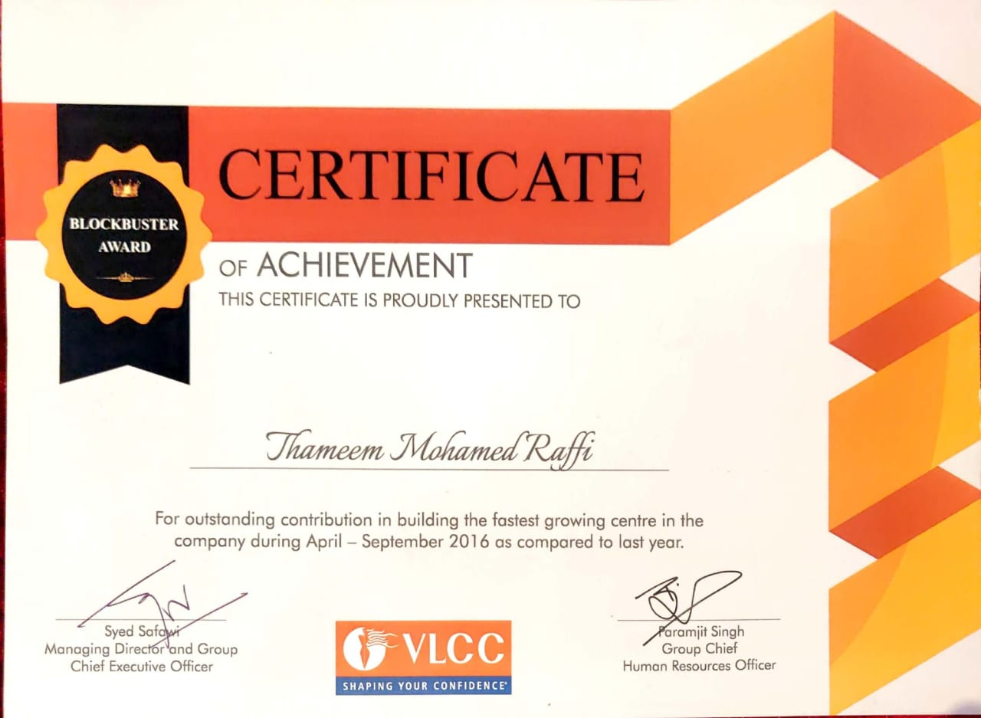

**Al Dheyaa Rehabilitation Center for Special Needs,Abudhabi,U.A.E.**

***Worked as the Unit in charge and as a Holistic Therapist from April 2006 till Sep 2007***

**Duties and Responsibilities:**

* **Ultimate responsibility for ensuring that clinics run smoothly and punctually.**
* **Continuous improvement of operational processes to ensure delivery of world class medical care and excellent customer service**
* **Ensuring quality of service and patient satisfaction are maintained**
* **Development of new operational processes as the needs of the business change and new services are rolled out or new locations are developed**
* **Handling non-clinical queries or complaints that are not handled at the front line**
* **Responsibility for staff welfare and development**
* **Responsibility for ensuring that all departments are adequately staffed at all times.**
* **Manage the annual staff appraisal process**
* **Liaising with department managers to ensure staff remain current with continuing professional development (CPD) and professional registration, as required.**
* **Ensuring all direct reports remain current with CPD and professional registration, as required**
* **Assist with recruitment of new staff**
* **Manage the induction of new staff and ensure their training is completed by the relevant member of staff**
* **Managing annual leave requests for direct reports**

**Excir Al Hayat Medical Centre, Abu Dhabi -U.A.E.**

***Worked as a Department Incharge & Holistic Practitioner from February 2005 till March 2006.***

**• Staff development & Training (Clinical,Non Clnical & Admin)   
• Staff performance management (Clinical,Non Clnical & Admin)   
• Goal Setting and individual performance appraisals   
• Communication of company messages within the practice   
• Employee Relations & managing conflict   
• Health & Safety compliance in conjunction with lead clinicians   
• Actively manage complaints  
• Obtain & review patient feedback via client survey as per procedure   
• Manage practice correspondence and administration   
• Effectively maintain equipment & manage reactive repairs   
• Facilitate ordering new equipment as necessary   
• Stock management   
• Effective communication with all key business relationships   
• Managing clinic budget and bank accounts  
• Ensure staff operate within all company policy and procedures   
• Audits as per policy   
• Activity management to meet client & revenue targets   
• Gather & analyze relevant activity data   
• Manage relationship & requirements at local level   
• Manage practice controllable costs in line with budgets   
• Practice accreditation**

**Al Falah Natural Treatment Center, Abu Dhabi- U.A.E.**

***Worked as Alternative Medicine In-charge from May 2003 to January2005***

**Duties and Responsibilities**:

* **Create and execute clinic related human resource and finance objectives and customer service.**
* **Guide and support participation in patient care delivery regularly**
* **Manage facilities, equipment, supplies, personnel and resources in relation to cost containment.**
* **Execute clinical administrative policies and initiate action to enhance patient care programs.**
* **Examine and resolve complaints received from staff, visitors, patients and physicians.**
* **Support policy formulation and execute budget by providing financial projections during budget development.**
* **Execute productivity increase strategies and optimize clinical staff and procedural value.**
* **Explain good workplace behavior and identify issues and use resources to resolve.   
  Understand future staffing requirements and create, execute and support clinical staff recruitment and retention strategies.**
* **Identify position specific job responsibilities and core competencies to create clear job descriptions.**
* **Improve staff - patient interactions through patient satisfaction tools.**
* **Handle environmental health and safety by ensuring fire and safety protocols are maintained**
* **Supervise stock supplies and handle clinic calendar.**
* **Establish and administer clinic specific policies and oversee system standard work**

**Ayda International , Abu Dhabi -U.A.E.**

***Worked as a Wellness Consultant for a period of 10 months (August 2002 to May 2003).***

* **To assist in the operational and administrative functions, activities, and projects**
* **Function as the clinic liaison with patients, Insurance companies, hospitals, and businesses**
* **Maintaining on-site Medical Records administration and ensuring that all regulations are followed**
* **Improve assisting in the development\implementation of cost effective policies and procedures for all administrative and operational areas**
* **Complete various special projects, which may require reviewing and analyzing information relating to alternative medicine.**
* **Identifying problems, recommending solutions and writing reports**

**India Multi-Speciality Centre in Chennai – India**

***Worked as an Alternative Medicine Consultant for a period of 6 years (June 1996 to August 2002).***

**PROFESSIONAL STRENGTH:**

* **Analyzing different data to facilitate the process of decision making for the top management in the facility**
* **Acting as a resource to the staff by providing relevant training, mentoring, assessment and development plans**
* **Ensuring that the work of the department/section is effectively and in a timely manner coordinated with other departments/sections**
* **Strong ability to train, direct , build and lead operations**
* **Thorough knowledge of wellness industry**
* **Superb interpersonal skills.**
* **Uncommon ability to coordinate work activities with other departments.**
* **Strong fairness, organized, and strong independent judgment.**
* **Remarkably professional with in-depth ability to work with a multi-cultural staff in a multi-task environment.**
* **Ability to organise, co-ordinate, implement and control work-related activities.**
* **With a dedicated team, able to achieve a considerable percentage of progress in the physical wellness and mental attitude of the clientele.**
* **Moreover, being possessed with optimistic attitudes, will impart the same feeling of optimism and positive energies in the clientele.**
* **quality control management, audit policy making, KPI’s training**
* **Will adapt to new environment and grasp work quickly.**

PROFESSIONAL QUALIFICATION

**Health care quality professional course**

**PG Dip.in Hospital Management & Health care quality management**

**Bachelor’s in science Alternative medicine**

**U.A.E.-Ministry of Health- Registration No. R-39704**

**DOH–Department of Health Abu Dhabi No. T2971**

REFERENCE

Available on request