AASAITHAMBI.A

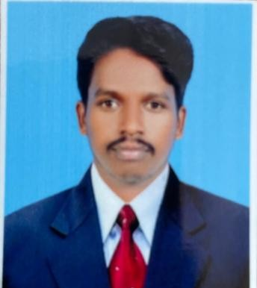

Contact

**Phone:+91 7200589251**

**Email:**

[physioaasai@gmail.com](mailto:physioaasai@gmail.com)

# Languages

English Tamil

# Hobbies

Professional Summary

With to join as physiotherapist and to work eith a centre of therapy that give a chance to improve knowledge and skills as a physiotherapist and climp up the ladder of success along with taking my organization to heights of popularity and respect

# Skills

|  |  |
| --- | --- |
| * Rehabilitation * Teamwork * Health care * Quality improvement * Nursing * Fitness care | * Administration * Sports injury * Exercise Therapy * Musculoskeltal * Work well independently |

Experience

* I have worked as Physiotherapist in Jayam Nature Care Hospital from 17-09-2020 to 05-06-2022
* I have workrd Sri Ram physiotherapist and rehabilitation Centre in Srivaikundam from 03-07-2022 to 09-05-2023

# Education

* Bachelor Degree Devendra college of Physiotherapist Tirunelveli under DR, M.G.R University 62% year of passing 2020
* Hsc Masood thaika Higher Secondary school State Board 72% Year of passing 2015 Kadayanallur

s

* Reading
* Playing
* Making
* SSLC Masood thaika Higher Secondary school Kadayanallur State Board 82% Year of passing 2013

**Certificate And License**

**__________________________________________**

* Convocation
* Transcript
* Member of Indian Association of Physio Therapy