CURRICULUM VITAE

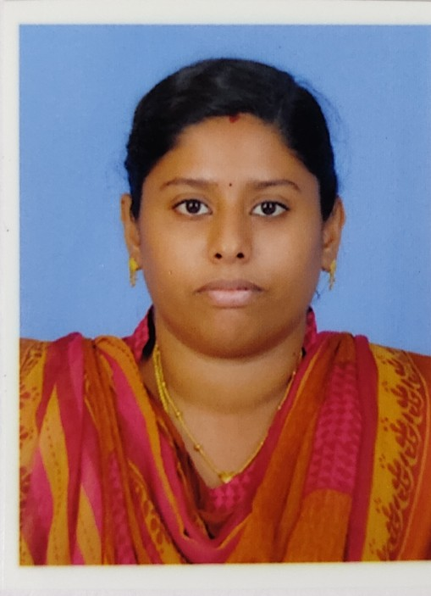 Mrs.ROSIN VARGHESE KOONAMMACKAL(H)

SINGHUKANDAM

SURIANALLY(P.O)

IDUKKI

KERALA 685618

**Mobile:7538837337**

**Email :rosinruby@gmail.com**

**PROFILE**

I am independent, God fearing, responsible labtechnician as well as a tutor.I have good observative, understanding and communicative skills to get along with different types of patients and colleagues.

**PRESENT EXPERIENCE**

**JIPMER -KARAIKAL ,PUDUCHERRY**

This is a central government medical collage with a good performing laboratory department. The laboratory department includes blood bank department of hematology,pathology, biochemistry, microbiology, forensic medicine, community medicine etc

**Date of Joining & period :1.11.2016 -30.06.2020**

**Type of Experience          :    Fulltime lab technician**

**Department                    :   department of labortary**

**Location : karaikal**

**WORK EXPERIENCE**

|  |  |  |
| --- | --- | --- |
| **HOSPITAL NAME** | **Duration [in years]** | **DEPARTMENT** |
| **MMT hospital mundakayam** | **13-06-2015 TO 13-06-2016** | **Laboratory** |
| **JIPMER KARAIKAL** | **1.11.2016 TO 30.06.2020** | **LABORATORY** |

**EQUIPMENTS WHICH I CAN HANDLE**

|  |  |
| --- | --- |
| * fully automated biochemistry analyzer{humastar200,olypus au400,Toshiba,bekman} * semi.auto analyzer{human,agappae} * fully.automated hormonal and cancer marker assay analyzer{minividas} * chemi analyser * ion selective electrode included electrolytes analyzers * cell ccounter,Microtome,ELISA READER,ELISA WASHER. Electrophoresis * Microtome,fully automated staining |  |

**SKILLS.**

* Careful handling of the sterile instruments and articles.
* Early planning and organizing things for emmergency
* Maintaining good communication with doctors, co-workers,patient and their relatives
* Informing the doctor concerned whenever necessary.
* Know to wear sterile gown and sterile gloves[open and closed method]
* Scrubbing, hand washing and aseptic precautions.
* Observation and concentration.onducting and supporting scientific investigations and experiments
* planning, setting up and undertaking controlled experiments and trials
* recording and analysing data
* demonstrating procedures
* collecting, preparing and/or testing samples
* maintaining, calibrating, cleaning and testing sterility of the equipment
* providing technical support
* presenting results to senior staff
* writing reports, reviews and summaries
* keeping up to date with relevant scientific and technical developments
* supervising staff
* carrying out risk assessments
* ordering and maintaining stock and resources

**ACADEMIC QUALIFICATION**

|  |  |  |
| --- | --- | --- |
| **Course** | **Duration [in years]** | **Institution** |
| **S S L C** | **2006 MARCH** | **ST:George H.S.S Manimala,kerala** |
| **Plus Two** | **2006-2007** | **C.C.M H.S.S Karikkattoor,kerala** |
| **B.Sc (MLT)** | **2008-2012** | **MTPG AND RIHS PUDUCHERRY** |
| **M Sc. Medical Biochemistry** | **2012-2015** | **JIPMER**  **PUDUCHERRY** |

M SC PROJECT WORK DETAILS

My M. Sc project work title

**CORTISOL, C-REACTIVE PROTEIN AND IL-18 LEVELS IN PATIENTS WITH CHRONIC URTICARIA**

**The project is published in the annals of allergy and immunology**

**ACADEMIC EXPERIENCE**

|  |  |
| --- | --- |
| **Name of the institution** | **Field of experience** |
| **IGMC PUDUCHERRY** | **MEDICAL LABORTARY TECHNICIAN** |
| **MATERNITY HOSPITAL (MH)PUDUCHERRY** | **MEDICAL LABORTARY TECHNICIAN** |
| **IGMC(PKMC)** | **MEDICAL LABORTARY TECHNICIAN** |
| **JIPMER** | **M.Sc MEDICAL BIOCHEMIST** |

**Hobbies**

1. Making friends
2. Playing cricket
3. Cultural activities
4. Driving

**STRENGTHS**

* Open to learn Good Communicational skill
* Positive attitude I know who I am
* Team building ability A good motivator

**PERSONAL PROFILE**

**Age : 28yrs**

**Date of Birth : 15-09-1991**

**Gender : FEMALE**

**Father’s Name : Varghese P.C**

**Marital Status : Married**

**Religion : Christian R.C**

**Nationality : Indian**

**Languages known : English, Hindi, Malayalam,Tamil**

**REFERENCES**

1. Dr. **Zachariah Bobby**

Professor and Head

Department of Biochemistry

JIPMER, Puducherry

1. **Dr. Medha R**

Associate Professor

Department of Biochemistry

JIPMER, Puducherry

1. **Dr. Laxmisha Chandrashekar**

Associate Professor

Department of Skin and STD

JIPMER, Puducherry

1. Sr. linate c m c

Laboratory in charge

M M T hospital

Mundakayam

5.Dr.satheesh Babu

Associate professor

Department of biochemistry

JIPMER,KARAIKAL

**DECLARATION**

I hereby state that the above mentioned information is true to the best of my knowledge. I humbly request your good self to permit a chance to work in your esteemed hospital.

Thanking You

Faithfully

Place : kerala

Date:30/06/2020

` Rosin Varghese