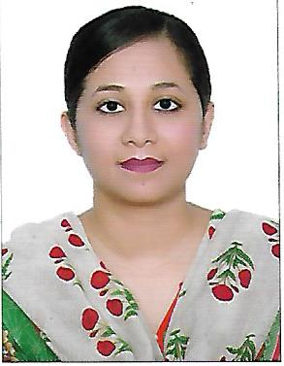Dr Sidrah Aijaz

Mob no: 058-8505414

Email id: drsidrah82@gmail.com

**Career Profile**: Energetic, highly-motivated and talented general practitioner. Over 5 years of clinical experience. Looking for a position in an organization where I can enhance my knowledge and skills.

**Education:**

**Sindh Medical College, Karachi**

* Completed M.B,B.S from Sindh Medical College

**St. Joseph’s College for Women, Karachi**

* Completed High School. With A grade

**Experience:**

**Dear Health Medical Center – Ajman, UAE**

* Worked as a General Practitioner.

**Zahra Medical and Dental Clinic – Karachi, Pakistan**

* Worked as General Practitioner.

**Worked at JPMC in obstt and gynae, Karachi Pakistan**

* I was appointed in ward 9, where we use to deal with patients in OPD
* Casualty and labor room, guided and taught 4th and 5th year medical students came for rotation in ward. I have assisted in cesarean sections and other operating procedures.

**Worked in Department of Medicine JPMC, Karachi Pakistan**

* I was appointed in ward 6. We use to deal with patient with chronic liver disease, diabetes, blood disorders, cardiovascular diseases, hypertension, infection and inflammatory diseases; stroke etc
* Acquainted myself with various diagnostic procedures like abdominal paracentesis, pleural fluid aspiration, lumber puncture and synovial fluid aspiration.
* In additional to internal medicine I spent 6 weeks each rotating through the specialized discipline of intensive care unit and attended specialty clinics held in ward (diabetes, endocrinology & rheumatology).
* Have worked in department of Psychiatry for the period of 3 months
* Good patient doctor relationship was maintained.

**Skills:**

* Complete knowledge Microsoft Word, Excel and Power Point
* With Valid UAE Driving license.

**Medical Council Registration:**

MOH license number **D53335**

**Visa Status:**

On Husband Valid Visa

**Languages**

English, Arabic and Urdu/Hindi.