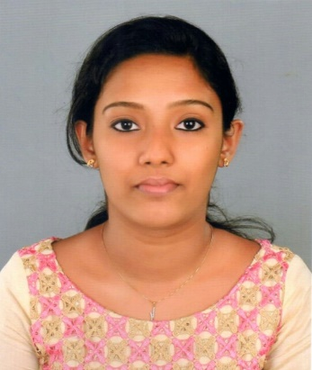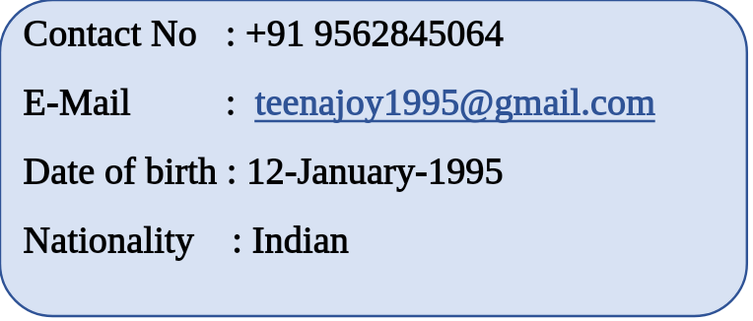





**CAREER OBJECTIVES**

* To work for an organization with people who are dedicated in solving complex business issues.
* To continuously develop the knowledge base and have an up-to-date knowledge and skills.
* To have a challenging and successful career in accounts, auditing, finance, banking and allied fields.

**WORK EXPERIENCE**

**JOSEPH MATHEW & CO. (Audit firm)**

**2 year and 4 months** (February 2017 - still continuing)

**Job Profile**

* Vouching the transactions
* Scrutiny of books of accounts
* Bank reconciliation
* Preparation of statement of final accounts
* Preparation of statement sundry creditors and sundry debtors
* Computation of tax (GST)

**CERTIFICATIONS**

* Completed 6 month course on **Diploma in Sales Tax Practice.**
* Successfully completed 3 month course on **TALLY.ERP9.**

**SKILLS & STRENGTHS**

* Working knowledge in **MS Excel**, **MS Office**
* Ability to learn fast
* Team player
* Honest

**EDUCATIONAL QUALIFICATIONS**

|  |  |  |  |  |
| --- | --- | --- | --- | --- |
| Qualification | Board/University | Institution | Year Of Passing | Aggregate |
| Master of Commerce  (M.Com) | Mahatma Gandhi  University, Kerala | Mahatma Gandhi  University, Kerala | 2017 | 63% |
| Bachelor of  Commerce (B.Com) | St: Mary’s College,  Manarcad | 2015 | 78% |
| 12th Grade  (HSE) | Board of Higher  Secondary Education,  Kerala | St: Anne’s G.H.S  School,  Kottayam | 2012 | 89% |
| 10th Grade  (SSLC) | Kerala State  Education Board | 2010 | 81% |

**PERSONAL PROFILE**

**Date of birth :** 12-01-1995

**Marital status :** Single

**Languages known :** English, Malayalam, Hindi

**Address :** Pallikkunnel House, Vadavathoor P O, Kalathipady

Kottayam, Kerala, India

686010

**REFERENCE**

CA Joseph Mathew FCA

JOSEPH MATHEW & CO.

Kottayam

**DECLARATION**

I hereby declare that the details furnished above are true and correct to the best of my knowledge and belief.