**Curriulum vite**

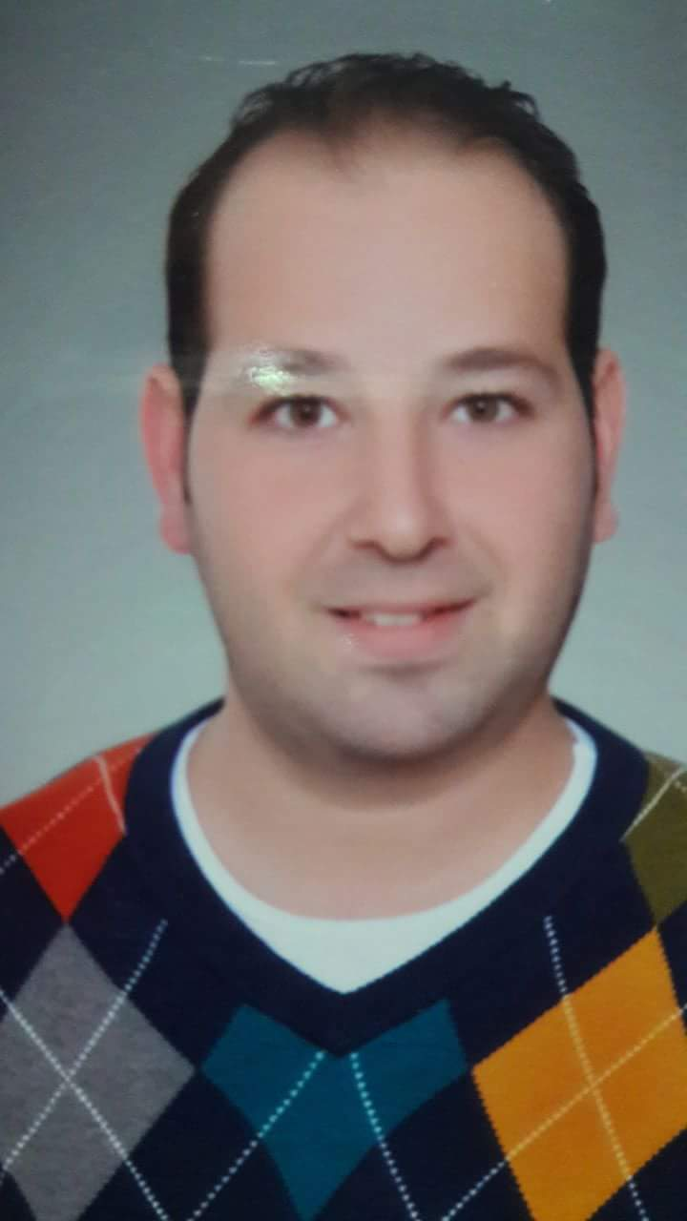

**PERSONAL INFORMATION:**

* **Name: Wael Mohamed Abd Al Azeem Abd Allah**
* **Date of Birth:** 3 - 7 -1985
* **Gender**: male
* **Marital Status:** married
* **Nationality:** Egyptian
* **Telephone number:** 00965 99166419 - 00965 96749656
* **Address:** Kuwait, Sabah Al salem, block 3, street 302, building 33
* **e-mail:** waelaaotes@gmail.com

**EDUCATION:**

|  |
| --- |
| * **MBBCh, Faculty of Medicine ,University of Alexandria, 2009.** * **Master of Radiodiagnosis and Intervention ,the Faculty of Medicine, University of Alexandria, May, 2016.** * **Ministry of health of Kuwait license as radiology registrar Valid till Sept. 2022.** * **Valid UAE ministry of health (MOH) evaluation letter since 5 April 2021.** |

**EXPERIENCE:**

|  |  |
| --- | --- |
| **House officer at Alexandria main university hospitals ( from Mar 2010 till Mar 2011).****General practitioner at El Agami medical zone, Alexandria (from Mar 2011 till April 2012)****Resident radiologist doctor at General Navy Military Hospital (from April 2012 to Oct 2014),** Alexandria.**Training at the Main University Hospital of Alexandria.****Resident radiologist doctor at Abou Keer General hospital (from Nov 2014 till Nov 2017),** Alexandria.**Radiologist at ALEX Scan (Alexandria Radiology Center) from Nov 2016 till May 2018,** Alexandria**.****Radiology registrar at Dar Alshifa Hospital in Kuwait (from july 2018 till now (Contract ends at july 2021)).** |  |

**SKILLS:**

* All Ultrasonographic examinations including: abdominal, pelvis, gynecological/obstetric, neck, scrotal and superficial examinations.
* 4D obstetric ultrasound examination.
* All Doppler examinations including: upper and lower limbs arterial and venous systems, carotid Doppler, renal Doppler and predialysis assessment for shunt and shunt assessment.
* All x-ray (plain and contrast based) examinations reporting.
* All CT examinations including of brain, abdominal and pelvis, head and neck, upper limb , lower limb, CT angiography and emergency reporting.
* Most of MRI examinations reporting including brain, abdomen and pelvis, MSK and spine reporting.
* Language:

Fluent in Arabic and English

|  |  |
| --- | --- |
|  |  |
| Computer knowledge: | Windows, Ms Office. |